載飛體驗安全檢視暨知情同意書
(正面)(Front)
Flight Experience Safety Inspection and Informed Consent Form
- 本人無心臟病、高血壓、氣喘、癲癇、頸椎傷害、懷孕、酒醉、身體不適或其他隱疾，且半年內無骨折。
- 本人了解無動力飛行傘具有不可抗力風險，並自主選擇參與本次載飛體驗。
- 本人將依照業者及專業人員之解說及指導協力配合進行本次載飛體驗。
- 本場地已投保責任保險(保額及投保範圍參見場地公告)；載飛體驗過程若產生個人或第三人之損害或傷病，本人同意依照規定申請保險理賠。
- 本人已受告知得依需求投保傷害保險或其他保險。
- 本人（及法定代理人）已詳讀並了解此同意書內容。
□ 同意參與載飛體驗
姓名： ________________________
本人或法定代理人簽名處： __________________________________
_________年__________月__________日
- I do not have heart disease, high blood pressure, asthma, epilepsy, neck injuries, pregnancy, intoxication, physical discomfort, or any other hidden illnesses, and have not had any fractures in the past six months.
- I understand that paragliding carries inherent risks, and I voluntarily choose to participate in this flight experience.
- I will follow the explanations and instructions provided by the operator and professionals and cooperate in the conduct of this flight experience.
- This facility has liability insurance (coverage amount and scope of insurance are specified in the facility's announcements); if any personal or third-party damages or injuries occur during the flight experience, I agree to apply for insurance claims according to the regulations.
- I have been informed that I may purchase accident insurance or other insurance as needed.
- I (and my legal guardian) have read and understood the contents of this consent form.
□ I agree to participate in the flight experience
Name: ________________________
Signature of participant or legal guardian: ______________________________
Date: __________ Year ________ Month ________ Day
載飛體驗安全檢視暨知情同意書
(反面)(Back)
Flight Experience Safety Inspection and Informed Consent Form
項目  Item | 檢視內容  Check Content |  |  | 受載飛者與載飛員簽名  Passenger and Pilot Signature
(一)安全教育  (1)Safety education | 載飛員/現場人員已完成載飛體驗安全教育。  The pilot/onsite personnel have completed the flight experience safety education. |  |  | 降落後簽名  Sign after landing
(二)著裝區 (2) Suiting up area | - 個人貴重或易掉落物品已收妥。  - 安全帽扣環已扣牢。  - 套袋之胸扣、腿扣、腰扣已扣牢。  - Personal valuables or easily dropped items have been securely stored.  - The chin strap buckle of the helmet is fastened securely.  - The chest buckle, leg buckles, and waist buckle of the harness have been fastened securely. |  |  | 降落後簽名  Sign after landing
(二)著裝區 (2) Suiting up area | 胸扣Chest Buckle | 腰扣Waist Buckle | 腿扣Leg Buckles | 降落後簽名  Sign after landing
(二)著裝區 (2) Suiting up area | 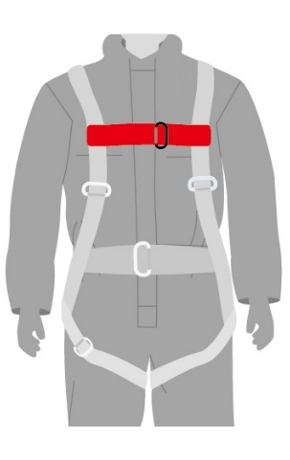 | 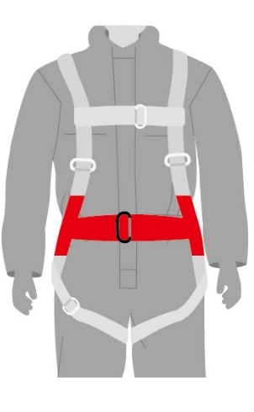 | 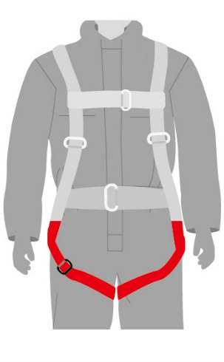 | 降落後簽名  Sign after landing
(三)起飛區  (3)Takeoff area | - 載飛員再次檢視安全帽扣環已扣牢。  - 載飛員再次檢視套袋之胸扣、腿扣、腰扣已扣牢。  - 載飛員確認與受載飛者已確實聯掛。  - The pilot checks again that the helmet chin strap buckle is securely fastened.  - The pilot checks again that the chest buckle, leg buckles, and waist buckle in the harness are securely fastened.  - The pilot confirms that the passenger is properly secured to him/her. |  |  | 降落後簽名  Sign after landing
(四)降落後  (4)After landing | 安全降落  Safe landing |  |  | 降落後簽名  Sign after landing

