栽植夢想 耕耘希望─偏鄉資訊萌芽

Bridging the digital gap in remote schools
教育部自民國90年推動「大專青年資訊志工」計畫，協助偏遠地區學校或社區改善資訊使用環境與資訊素養，目前已有445支青年資訊志工團隊、5000位以上青年擔任資訊志工，前往近800所偏鄉學校進行數位服務。
In 2001, The MOE started promoting the College Information Volunteers program to help improve the availability of digital information in remote schools and communities.
Over 5,000 young volunteers in 445 groups have gone to nearly 800 rural schools in an effort to help bridge the digital gap.
身殘心不殘 志工愛心灌溉偏鄉
Disability not a problem for volunteer work
嘉義縣私立弘德高級工商職業學校學生盧俊崴，雖智力不足，且有視覺障礙，但他也是「弘德工商資訊志工團隊」的一員。盧俊崴會使用多項軟體、組裝及修理電腦，還擁有TQC、網頁設計等證照。團員志工表示，和盧俊崴一起擔任志工，讓他們都很感動，並且更熱愛生命。
Despite his mental disability and visual impairment, Lu Jun-Wei, a student of Hung Der Technical & Commercial High School joined the Hung Der Information Volunteers.
Lu is skilled in the use of computer software and in assembling and fixing computers. He also holds a license in TQC and webpage design.
The other volunteers who worked with Lu said that they were moved by Lu’s passion and this has helped them develop a deeper appreciation for life.

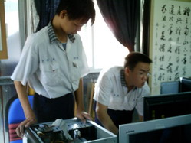 | 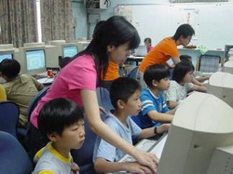
儘管盧俊崴（左）是視覺與智力障礙，但卻樂在服務，幫助別人 | 資訊志工不畏辛苦，遠赴偏鄉教孩子電腦技能
服務，就是在別人身上看見自己的責任
Service is being responsible for others
靜宜大學資訊傳播工程系王薏婷， 到台中縣清水鎮吳厝國民小學擔任志工，規劃營隊活動，以遊戲方式把電腦資訊介紹給小朋友，並動手替他們替鋪設網路線、組裝電腦。她也建議，學校應該提供更多機會讓學生充實知能，讓學生培養可以幫助別人的能力。
Wang Yi-Ting, a Computer Science & Communications Engineering major at the Providence University, joined her classmates for volunteer work at the Wu-Cu Elementary School in Chingshui Town in Taichung County. .
Through group games, they taught the kids basic computer skills, computer assembly and setting up Internet connections.
“I hope schools provide opportunities for their students to develop skills they need in their lives and in helping others,” said Wang.

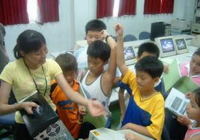 | 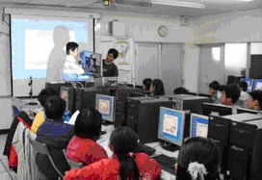
志工熱心服務，希望透過自己的專業，讓孩子走出去，世界走進來 | 資訊志工為孩子講解電腦知識，孩子接觸最新訊息
活到老學到老正在流行
We’re never too old to learn
國立嘉義大學資訊管理系林家緯在數位機會中心教小朋友電腦，其中不少媽媽，甚至白髮斑斑的老爺爺都是他的學生。老爺爺說，儘管上課經常跟不上小朋友的進度，但他還是每週都來，想學更多東西。
Lin Jia-Wei, majoring in Management Information Systems at the National Chiayi University, teaches at a digital opportunity center in Chiayi. His students include kids, their mothers and even their grandfathers.
“It’s hard for me to catch up with my classmates,” said an elderly man in Lin’s class, “but I still come here every week because I learn something new.”
林家緯表示， 老爺爺和媽媽們很珍惜學習機會，比小朋友還認真，現在他們有了新管道和新能力，可以探索世界的另一端。
“The seniors appreciate learning opportunities more than the young people and they are usually more diligent,” said Lin, “and this is their chance to learn about the digital world.”

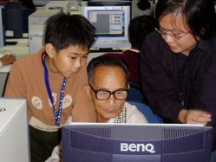 | 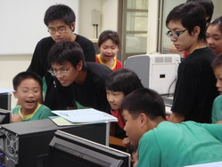
活到老，學到老，終身學習已經蔚為風潮 | 國立嘉義大學資訊志工團隊進行電腦教學活動

