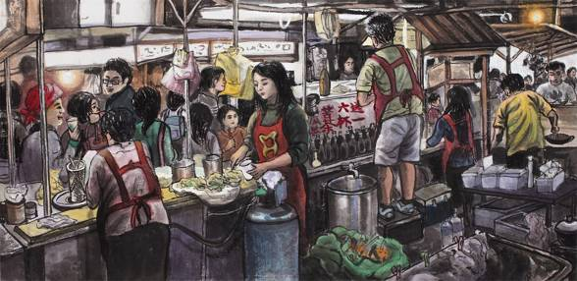
“Night Market”-- Silver
This work depicts the lives of people who make a living in a night market, where all sorts of products and foods can be found. In the hustle and bustle, street vendors and customers interact.

“Fireworks at Taipei 101”---Gold
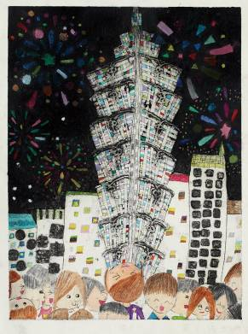
Taipei 101 is the tallest building in Taiwan. The annual fireworks show at the architectural masterpiece presents the energetic side of Taipei.

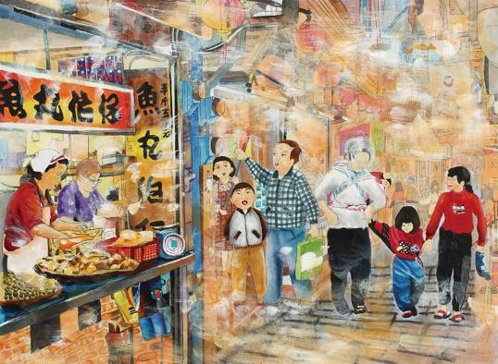
“Impressions of Jiufen (九份)”---Gold
Jiufen (九份) is located in Ruifang (瑞芳) District, New Taipei City. In the early 20th century, it abounded with gold mines. Now, it has become a popular tourist attraction. Fish ball stores in the Jiufen Old Street are a perfect example of traditional Taiwanese food .
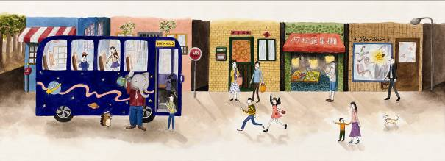

“A Falling Star” ---Gold
Inspired by a picture book, this painting illustrates a story of senior high school students who study hard to become astronauts, hoping to realize their promise to a friend – a star.

