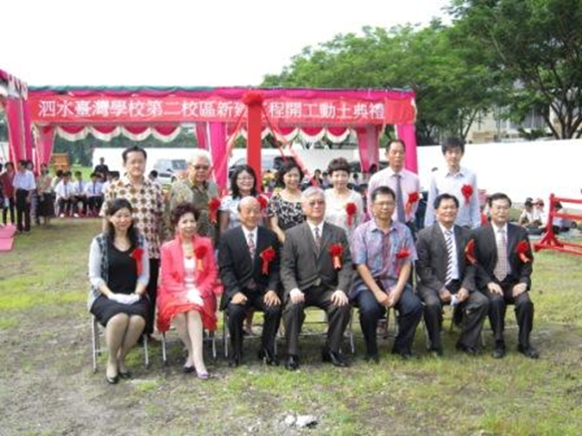
In the front row from the right are Malaysian Culture Specialist Chu To-ming (朱多銘) of the Taipei Economic and Cultural Office in Kuala Lumpur, Malaysia, STIS Founder Huang Shun-liang (黃順良), STIS Board of Directors chairman Lee Yuh-lin (李玉璘), Taipei Economic and Trade Office, Indonesia Representative Andrew Li-Yan Hsia (夏立言), STIS Foundation chairman Lu Chuang-siong (呂窗雄), and Buddhist Tzu Chi Foundation Surabaya Person in Charge Fan Xiao-hui (范曉慧).
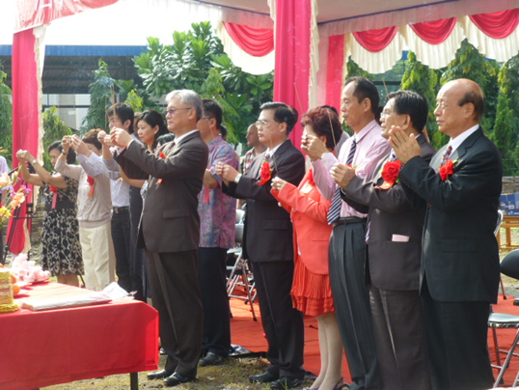
Indonesia Representative Andrew Li-Yan Hsia (夏立言) hosts the beginning of the construction ceremony, praying that it will be a success.

