Education in Taiwan
2015-2016

Contents
04 / Words from the Minister
06 / An Overview
08 / Educational System
11 / Education Reform
17 / Compulsory Education
21 / Senior Secondary Education
26 / Higher Education
33 / Lifelong Education
37 / Special Education
39 / Sports Affairs
44 / Youth Development Affairs
49 / Education Expenditures
50 / Teacher and Arts Education
53 / Study in Taiwan
57 / Vision
58 / Statistics
04 / Words from the Minister
Innovative Education - Creating Uniqueness

Education is the foundation of a nation, and our human capital is the force behind our prosperity. Education administrative organizations need to foresee how the future is unfolding and use more innovative approaches to planning for the national education system. The education system should help children develop their potential and others’ well-being. To help children and teens find their own path as they become young adults, the Ministry of Education is integrating its strengths in three areas – educational vitality, athletic vitality, and youthful vitality. Building on its governance achievements of the past, the Ministry is working to revolutionize the education system. Its aim is to create robust quality educational strategies, improve administrative efficiency, and actively implement and promote national education, sports, and youth development.

High-quality education is a component of the President’s Golden Decade National Vision that was unveiled in 2011 and the Ministry of Education is energetically working in all areas of education to provide this. Our recent work includes implementing: 1. the Early Childhood Education and Care Act, and the Quality Preschool Education Development program; 2. establishing quality education environments, and extending basic education up to grade 12; 3. the Technical and Vocational Education Act, and Phase 2 of the Technological and Vocational Education Reform Plan; 4. The Aim for the Top University, and the Promoting University Teaching Excellence projects; 5. amending of the Family Education Act, and establishing locally available ongoing learning and education for all senior citizens; 6. The Study-in-Taiwan Enhancement Program, and the 8-Year Chinese Language Education Export Plan; 7. the White Paper on Teacher Education; 8. Phase I of the 5-year Aesthetic Education Plan to boost arts education; 9. the E-learning Promotion Plan, and the Expansion of Digital Opportunities in Remote Areas project; 10. The Special Education Act, and setting up of an effective support system; 11. Amending of the Education Act for Indigenous Peoples, and implementing and promoting the 5-year Indigenous Education Development Program begun in 2011; 12. Drafting of the Student Guidance and Counseling Act which has now been promulgated, and creating sustainable friendly campuses; 13. Promoting the Sports Island Project, and implementing the Physical Education and Sports Policy White Paper; and 14. Drafting of Youth Policy Guidelines, and vigorously working to facilitate provision of a diverse range of development pathways for young people.

2015 has been designated the Ministry’s Education Innovation Action Year. We will steadfastly continue our professional collaboration with multifaceted creative approaches, and explore tackling our work in new ways, with new ways of thought, using new media, working with new people, and new perceptions. The Ministry of Education’s key role is to communicate policies and provide a plat form bringing together resources: integrating and putting to use various resources from all different sectors, and presenting forward-looking extremely practical government policies that will bring about noticeable positive changes in education. We are throwing our energy into turning our schools, colleges, and universities around with innovative education action, to help our young people to fulfill their dreams, increase their global competitiveness, and build an equitable, sustainable, and prosperous country.

Se-Hwa Wu, Ph.D.
Minister of Education
August 2015

06 / An Overview

The Ministry of Education is par t of the Executive Yuan and is responsible for national academic and educational administration, including education policy planning and legislation and supervision of educational matters.

Education has always been highly valued in Taiwan. Our education system is currently a 6-3-3-4 structure which offers compulsory education as well as teacher training and vocational education. Although preschool education is not part of the compulsory education and educational system, the government provides assistance to toddlers in financially disadvantaged families to enter the school system early, which has led to an increase in the number of pupils attending preschools enrolling children from age 2-6. On Jan. 1, 2012, kindergartens and nurseries were integrated as preschools into the education system. Elementary school lasts for six years, from age 6-12; junior high school three years, from age 12-15; compulsory education was extended to 9 years in SY1968, which includes elementary and junior high school; in SY2014 the period was extended to 12 years to cover senior secondary school. Senior secondary school lasts for three years between the ages of 15 and 18; university undergraduate education is four years, master’s level graduate education one to four years, and doctoral education two to seven years. In addition, to offer the general public a broader range of continuing education options, there is also supplementary education and continuing education as well as special education for students with special needs due to extraordinary talent or mental/physical disability. Widely available lifelong learning courses give the general public an opportunity to extend their learning experience.

In SY2014, the total number of schools, including preschools is 11,078, the record of the lowest number of students in 34 years, with a total of 4.73 million students, while the ratio of new immigrants’ children exceeds 10% of the students’ population. There are approximately 300,000 teachers nationwide. The percentages of teachers with master’s degree or above in elementary schools, junior high schools and senior secondary schools are 48%, 45% and 55%, respectively. The percentage of teachers in universities, colleges, and junior colleges with Doctoral degree and above is 74%, which is an increase of 20% compared to 10 years ago. Additionally, the higher education institutions have been trying to improve the international ambience of the campuses; there is an increase in the number of foreign educators recently. In SY2014, there is an increase of 8.8% in the number of foreign teachers compared to 2006, either full-time or part time position.

In the face of globalization of education, the government recently is trying to promote the export of higher education in recent years. Foreign student enrollment is increasing because of measures that attract foreign students, such as the establishment of a friendly study environment, a subsidy for overseas promotion by universities, colleges and junior colleges, encouragement for schools to increase their enrollment quota, and additional scholarships for foreign students. As of 2014, the number had reached a new height with 92,685 students, which is about 6.9% of the total universities, colleges and junior colleges enrollment.

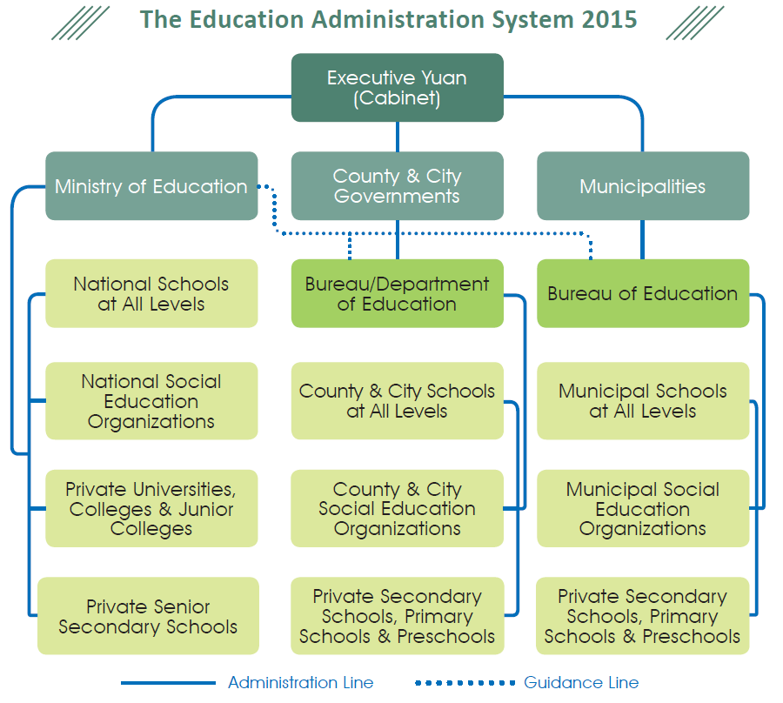

08 / Educational System
Students may study, under the current education system, for up to 20 years, which includes 6 years of primary education, 3 years of junior high school, 3 years of senior secondary school, 4 to 7 years of college or university, 1 to 4 years for a master’s degree and 2 to 7 years for a doctoral degree.

- Compulsory Education
A 9-year Compulsory Education system was put into effect in SY1968, of which 6 years are for elementary education and 3 years for junior high school. To offer more diverse development opportunities for junior high school students, technical arts education is included as well, in addition to the regular curriculum. Practical classes allow students to better understand vocational education and their future career choices. 12-year Basic Education was carried out in SY2014.

Senior secondary education consists of three years of schooling and includes “regular senior secondary schools,” “skill-based senior secondary schools,” “comprehensive senior secondary schools,” and “specialty-based senior secondary schools.”

- Junior College Education
Junior college education can be classified according to admission requirements into 5-year junior colleges and 2-year junior colleges. 5-year junior colleges admit graduates of junior high schools, whereas 2-year junior colleges admit graduates of skill based senior secondary schools.

- Teacher Education Programs
The teacher education system, comprised of multiple providers, serves to screen potential teacher candidates and establish a pool of prospective teachers. Teachers who teach in preschool, primary school, junior high school, and senior secondary school are trained in universities of education with teacher training programs or centers. These institutions are also responsible for providing in-service training and guidance for local education practitioners. In December 2012, the Ministry published its White Paper on Teacher Education, which focuses on pre-employment training, counseling-infused teaching, teacher’s professional development and support system with 9 development strategies and 28 action plans to provide a comprehensive plan for the education of teachers at all levels and for all subjects. To protect the teacher’s professional status and the student’s right to education, the Ministry will promote a professional development evaluation system for teachers in primary and secondary education. As a response to the implementation of 12-year Basic Education in SY2014, the Ministry will improve professional knowledge and skills for effective teaching, multiple evaluations and differentiated knowledge among teachers.

- University/College and Graduate School Education
The maximum study period for university education (including universities, colleges, universities of technology, and technical colleges) is 4 years (the Post-bachelor Second Specialty Program is 1-2 years, while the bachelor ’s program is usually 2 years), and internships can last one-half to 2 years depending on the needs of the subject. For Master’s Degree candidates, the study period is 1-4 years and for Doctoral Degree candidates the duration is 2-7 years.

- Special Education
Special education institutions are established for students with mental and/or physical disabilities, and offer education at the levels of preschool, primary school (6 years), junior high school (3 years), and senior or vocational high school (3 years). Moreover, students with disabilities from all educational levels may apply for extensions according to their mental and physical conditions, learning needs and willingness.

- Arts Education
The goals of arts education are to cultivate artistic talent, enrich the spiritual lives of citizens and elevate the cultural level. Arts education in Taiwan can be divided into professional arts education offered at schools, general arts education offered at schools and arts education offered to the public.

- Supplementary and Continuing Education
Supplementary and continuing education institutions provide extensive and comprehensive learning opportunities for the general public. This kind of education can be divided into general supplementary education, continuing education, and short term supplementary education.

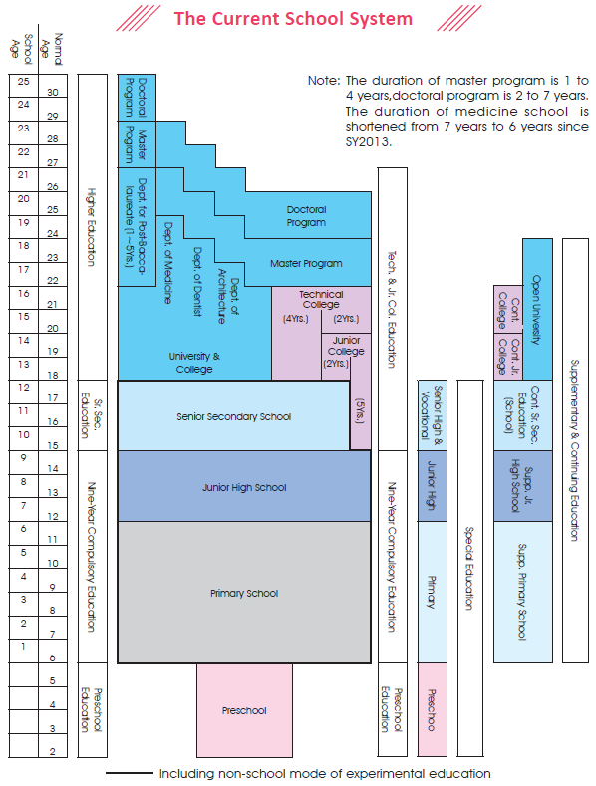

11 / Education Reform
- Implement White Paper on Human Resource Development to Actively Nurture Top Talent
Encourage and subsidize local government to establish non-profit preschool in cooperation with the civil and government forces to provide impartial and excellent child education and care services; modify branch laws and supplementary measures of Technical and Vocational Education Act to cultivate more technical talent; develop Higher Education Innovation and Transformation Regulation to solve the problem of sub-replacement fertility, the referral system of talent, and the management of the schools; enables school administrators to operate with more flexibility and with the rights to add new forms of usage to the school buildings. The authority is planning to organize a model for nurturing talent in universities, colleges and junior colleges and to encourage youth to publish their “micro movies” to present a variety of stories and create a platform for the youth exchange.

- Fully Implement Early Childhood Education and Care Act and Provide Quality Preschool Education and Care
Subsidize the facilities of preschool to improve the learning environment so the basic facilities of preschools can reach the standard of the law. Continue to expand the functions of the Early Childhood Educare web, which shares more useful information (both the policies and information on raising a child) to the public and educators so as to facilitate their understandings to the countr y ’s preschool education policies, ideals, and detailed information. Build more publicly-owned preschool; reduce the gap of the numbers between the publicly-owned preschool and privately-owned preschools; encourage and subsidize non-profit preschool to be built; support married women to go back to work while the government calms the worrisome hearts of the working parents with good preschool services and after school service.

- Implement 12-year Basic Education to Revitalize Teaching and Adaptive Development
Encourage junior high school teachers to actively modify their teaching methods in order to motivate the students’ learning motives, participation and boost their results. In additions, the schools should actively provide teachers with administration help and supports; encourage teachers to advance their professional skills; intact with their teaching goals; and formulate effective discussion to guide students to discover their independent learning skills. Teachers shall plan a specific assessment guide for each student; uses proper learning evaluation methods to evaluate the results; design and implement innovative ideas for various lessons and activities to increase the effectiveness of learning. The authority also promotes a multi-admission program and adaptive development and commands the schools to help students choose appropriate educational programs after graduation and to achieve the goal of tailoring learning based on their aptitudes.

- Enhance the Connection between Industry and Academics to Build Quality Recruits
To respond to the industries’ demands, reduce the gap between industries and academics for youth, nurture talent for industries and support the transformation of industries, promote interdepartmental cooperative platform and the formation of closer partnership with industries and academia is in place. The vertical guidance of the policies will steer the developments of various industries and help them to solve their current problem and needs of human resources. Establish industrial colleges at universities and colleges of technology, junior colleges to focus on industry’s human resource needs. Tailor and match a specific curriculum that is employment oriented. Conduct employment-oriented curricula in vocational secondary schools and encourage schools to collaborate with industrial organizations and training organizations as well as universities, colleges and junior colleges to devise employment-oriented curricula that focus on practical skills. Students may obtain onsite work experience, internship opportunities in industry, and training opportunities or field experts may be recruited as faculty for the courses.

- Promote the Innovation and Transformation of Higher Education and Nurture World-class Talent
Develop the higher education innovation and transformation regulation; encourage university faculties to implement experimental education; promote partnership between industries and academic circles; adjust the ratio of students and teachers to raise the teaching qualities to solve the trend of sub-replacement fertility; enhance students’ global mobility and nurture world-class talent; create channels to improve students’ English ability and second language acquisition; develop methods with international academic institutions and industries to raise cross-borders talent; bestow university faculties more flexibility in developing admission procedure for students with
different education backgrounds and abilities; assist underprivileged students in admission; continue to promote diverse channels for faculty promotion; establish a robust system for the university evaluation to ensure the promotion system of the educators is diverse, fair and transparent; modify the flexible salary system.

- Elevate Teacher Training and Raise the Aesthetic Quality in Education
Plan and establish a database for teachers in junior high schools and below; integrate the important databases and conduct value-added applications on information related to teacher training that will be used as an evaluation mechanism for the teachers’ demand. Through the integration and comparison of varied data, the background, experiences, training, professional development of the teachers of the data can be used to predict education-related problems in the future as a reference of teacher training policies. Establish a complete SOP for teacher certificate issuance and a sound inspection mechanism for teacher qualifications, and strengthen continuing education mechanisms for teachers to improve teachers’ professional skills and knowledge. Expand the evaluation of teachers’ professional development, promote the teacher evaluation system and implement the Phase I of the 5-year Aesthetic Education Plan.

- Encourage Senior Citizens Learning and Family Education and Establish a Society with Lifelong Learning
Assist the local government in focusing on the family value education while promoting enhancing family education values and service, popularize the execution of parental education and marriage education, and the development of the prevention and support program for family education. The Ministry will guide the local government through our family education guidance team on district basis. Broaden the information on the family education website of the Ministry and the local governments; enhance the public’s knowledge on the usage of family education services; supervise the local governments’ effort on developing the community colleges to provide more diverse lessons, raise the society’s quality and create an inquisitive society. Try to organize events for senior citizens learning which integrate social enterprises and cross generation interactions.

- Promote E-learning and Promote Cross Fields Education Innovation
Implement w i r e less access point and enhance Wireless Lan capability in order to boost the coverage of wireless internet across campus and continue to assist mobile learning. It combines the campus cloud service which the wireless environment is used to support mobile learning in school. Integrate the digital resources of the Ministry, municipal, county and city governments as well as affiliated agencies and academic circles to promote innovative ways for learning; nurture humanities, social science and technological cross fields talent and learn to collaborate with professionals from various domains. The society and the industries will be more innovative and through the collaboration and the applications of resources and know ledges from different professions.

- Establish Friendly and Sustainable Campus to Promote Students’ Physical and Mental Health
Promote the planning, organizing and responsibility of the counseling programs in schools according to guidelines; prepare, plan and execute student counseling through training. The counselors training fund will be given priority in budget planning. The method of on the job training will help the trainee to professionalize counseling which in turn will increase the student counseling quality and efficacy. The student counseling services should promote healthy and well-rounded development for the youths; the Ministry will assist schools and education departments in the promotion and execution of student counseling services to create a more versatile system.

- Deepen Multicultural Education and Bring about Social Justice and Care
Education is the key to breaking social classes through increasing flows among the social class structures. The Ministry of Education is keen on integrating the government with the resources in the civil society to execute the proposals related to education of the aborigines and the child education support for the new immigrants. At the same time, the Ministry pushes for multiple educational assistance measures, subsidizes varies expenditures of the disadvantaged students so they can have a chance to receive an education, provides a sound educational environment for students with mental or physical disabilities to give them an appropriate development. Improve learning and academic performance for disadvantaged students; provide assistance to effectively distribute rural and urban educational resources for low income families, single parents, children without parents, grandparents rearing, and latchkey kids.

- Stimulate Sports Development to Citizens and Performance in International Sports Events
Activate national sports training center which strongly believes in becoming a progressive world-class professional training institution that shall nurture and raise talent and Taiwan’s competitiveness in the international sport fields. Promote national athletes training affairs; execute Sports Industry Development Regulation; promote sports development guidelines; boost the development of the sports industry; increase the participation rates of students with disabilities; continue to increase the abilities of physical education teachers; assist the recruitment of athletic trainers for senior secondary school sports classes to care for the athletes’ career; to shift funds to athletes’ team and well-equipped sporting facilities for schools.

- Establish Youth Development Platform to Nurture Multiple Abilities
Conduct and organize Youth Development Indicator Research to build guidelines that are suitable for the youths; continue to subsidize academic institutions, universities, student groups or clubs, and legal entities to organize training, events, seminars and courses that promote youths’ participation and interest in public affairs; continue to promote activities that endorse youth t ravel experiences; encourage the youth to experience and explore Taiwan from a different angle which in turn boost their sense of responsibility and cultural identity.

17 / Compulsory Education

- General Information
The infrastructure of a country and the development of its economy are a function of the country ’s cultivation of manpower and talent. This requires long term, continued investment and needs to start from the very bottom. The government set the length of compulsory education at 9 years in SY1968, and will further extend it to 12-year Basic Education in SY2014, which will help nurture and develop the manpower needed for economic growth.

Ensuring that all toddlers receive proper preschool education is a major objective of our educational policy. Kindergartens are preschool institutions set up in accordance with relevant legislation for children aged 4 and above up until the eligible age for elementary school, and are supervised by education administrative authorities, whereas nurseries are welfare organizations set up in accord with Children and Youth Welfare Act that accept toddlers aged 2 to 6 and are supervised by social administrative authorities. The talks and negotiations for merging nurseries and kindergartens started in 1997, and culminated in the Early Childhood Education and Care Act passed on June 29, 2011, to be put in place beginning Jan 1, 2012.

- Preschool and Compulsory Education Structure
The Early Childhood Education and Care Act is a revolutionary move in our preschool system. After the bill was enacted on Jan 1, 2012, nurseries and kindergartens were re-designated “preschools”, in which toddlers from the age of 2 onwards are given complete and thorough education and care in the preschool until they enter elementary school. This bill consolidated the education and care of toddlers under a single administrative system, putting into practice a toddler-centered strategy that focuses on the toddler’s best interests. Taiwan is also the first country in Asia to consolidate the two systems.

According to statistics by UNESCO, there are over 40 countries in the world that have a basic education system that exceeds 10 years. The main reason for this is that many non-developed countries have noticed that basic education is directly connected to national competitiveness.

Put into practice in SY1968, Taiwan’s 9-year Compulsory Education system is compulsory, free and obligatory. Legislation states that citizens from the age of 6 to 15 should receive compulsory education; which is divided into two stages – the first 6 years at the elementary school level, and the latter 3 in junior high school. However, this system has been in place for over 4 decades. When first put in place, there were fewer than 10 countries worldwide with more than 9 years of compulsory education in place, making us one of the forerunners. Compared with developed countries, however, the number of years was not that high. To solve the current educational conundrum and enhance the development of national manpower, a 12- year Basic Education system was adopted in SY2014, a new landmark for our education system.

- Preschool and Compulsory Education Policies
Under Taiwan’s educational setup, preschool education is not compulsory. The education and care of preschool-aged toddlers was originally provided by, respectively, kindergartens and nurseries, largely consisting of privately-established inst i t u t ions. As the two systems were separate and had different supervisor y administrative units, they evolved different set-up standards and have different regulations regarding personnel and curriculum. Thus toddlers of the same age often received inconsistent education and care at different institutions. Also, internationally, the trend of offering educare service has become a common scene. We thus started to promote the integration of early childhood education and care. The integration is aimed to be completed within 14 years.

To stimulate the development of junior high and elementary school education and improve its quality, and lay the groundwork for course planning, fundamental research in the development of elementary and junior high school curricula was carried out and added to the 12-year Basic Education policy strategic plan in 2012 to allow the National Academy for Educational Research to complete the Proposal for 12-Year Basic Education Curriculum Development and Guidance for 12-year Basic Education Curriculum Development to ensure consistency.

With increasing globalization in recent years, many nations are experiencing a growing income gap between the wealthy and the poor as well unequal resource distribution between town and country. Geographical factors and rapid changes in society can lead to uneven distribution of educational resources, causing an educational imbalance between town and country and depriving minority groups of equal access. To solve these regional education issues and bridge the resource gap between different locations, we are working to put the following into practice: reasonable distribution of educational resources, equality in educational opportunity, and realization of equal education and a just and fair society.

Another key strategy is the idea of social care and assisting in the education of children from economically disadvantaged families. Currently there are 3,440 schools participating in the Promoting School Education Savings Account project nationwide, which authorizes the schools to receive charitable donations. Many philanthropists in both business and society have been long term donors to children in the program, a testament to the generosity of the people of Taiwan.

Young Inventor Saves Vision with Reading Correction Device
As phubbers are everywhere nowadays, eyesight protection has become an urgent issue. Sixth grader Chen Po-juei from Kaohsiung Municipal Sih-Wei Primary School has invented a reading correction device, offering a solution to the widespread phenomena and won the Golden Award of the International Exhibition for Young Inventors held in Jakarta, Indonesia in 2014.

The device will alarm with LED lighting when the reader’s overly lowering head is detected by the incorporated Infra-Red Radiation, and a vibration reminder will be activated in case the reader falls asleep accidentally.

Chen’s brainchild originates from his personal experience as he often forgets to keep appropriate distance while doing homework. Throughout the entire inventing process, to incarnate a mere idea into reality is the most difficult yet the most unforgettable part when it gradually took form, said Chen.

Stepping into the realm of invention, the young inventor is inspired by his father, who always encourages Chen to “invent it yourself” whenever the young inventor got some questions popped out in his mind.

Participating the international event, Chen was impressive with the variety of creation from many different countries. “Every single contestant was creative, which inspired me with many ideas for my next invention,” he said.

Chen is not the only one who’s advantaged from such an event. It’s an unusual experience to lead students to an international competition, which turned out to be a very rewarding one, said instructor Yang Kuangyu. Not only students were able to interact academically and culturally with peers from other countries, teachers also seized the chance to exchange ideas on education and culture issues with one another, recalled Yang.

Curiosity-led Scientific Fun Enriches Schoolchildren’s Life
The diligent elaboration into the phenomena of liquid being solidified as well as solid being liquidized won the five-member team the 1st place at the Primary School Division of 54th National Primary and High School Science Fair.

“Sufficient preparation beforehand has made the final work more sophisticated, which is one of the keys to win,” said Instructor Chang Hsen. “When we encountered difficulties in experiments, we brainstormed for solution. Repetitive correction, practice, and reflection has enabled the team to submit a detailed research result. Camaraderie among team members built up over the yearlong preparing is another strength to outperform other contestants, said the instructor.

Despite the long-term preparation exhausted us, we’ve acquired a great deal of knowledge and learned how to deal with setbacks, said participating students, who all were 6th graders then. Competitive presentations from other groups didn’t hold them back, instead, they went straight forward to meet the challenge.

“Our eyes were welled with joyful tears when our names were announced on the declaration day and had the feeling that all our effort were paid at last,” recalled these young scientists.

Chang contributes the triumph to the team’s hardworking and support from their parents, the school and her colleagues. “I expect students to personally experience the fun of learning,” said Instructor Cheng, continuing that “and feed their curiosity.” The capabilities and confidence built through the process will become invaluable treasure in their future.

21 / Senior Secondary Education
Senior secondary education is designed to cultivate physically and mentally sound citizens, laying the foundation for academic research and the acquisition of professional knowledge in later years. Senior secondary schools can be divided into “regular senior secondary schools,” “skill-based senior secondary schools,” “comprehensive senior secondary schools,” and “specialty-based senior secondary schools.” Students who graduate from junior high school or have an equivalent education level can gain admission to senior secondary school through methods such as examination-free entrance, specialty enrollment. 160 credits are required for graduation.

- Advanced Science Education and Cultivation of Talent in the Science
- Taiwan has achieved outstanding results in the International Mathematics and Science Olympiad. Domestic mathematics and science competitions are frequently held for senior secondary school students, and there are also science talent cultivation plans and domestic and international exhibitions to stimulate interest and learning in the sciences.
- Key objectives for the year 2015:
- Continue training students for the Math and Science Olympiads, and organize similar domestic competitions in mathematics and information technology for junior high school and senior secondary school students.
- Continue supporting secondary and elementary education projects in science and cultivation programs for scientific talent.
- Set up science programs in senior secondary schools and monitor the effectiveness of the programs.
- Set up “Classes Preparatoires aux Grandes Ecoles” selective exams.

- Bring Second Foreign Language Education into Practice and Improve Students’ International Awareness:
- The main goals of the fourth phase 5-year plan is to “Improve Second Foreign Language Education in Secondary Schools” include the following:

- Encouraging schools to adopt the plan and offering them support.
- Strengthening the promotion mechanism for the second foreign language education system.
- Creating a second foreign language learning environment.
- Improving the teacher recruitment system.
- In SY1999, a total of 22,623 high schools students enrolled in 648 second foreign language classes, a number which ballooned to 112,980 students with 3,760 classes by SY2012, which is 4.97 times the number in SY1999. In SY2013, nine universities, colleges and junior colleges applied to offer 36 advanced placement foreign language classes for high school students.
- Key points for the year 2014~2015:
Continue encouraging schools to teach more foreign languages and offer more foreign language classes in order to cultivate talent and increase international competiveness in the area of languages.

- Practical Technical Program and Cooperative Education
Practical Technical Program
These programs impart practical skills to students who choose the technical arts curriculum in junior high school, providing them with the means to enter the job market and secure employment. Instruction is provided via day classes or evening classes, and students are eligible for graduation after completing 150 credits in 3 years.
Cooperative Education (Alternative Classes)
These classes were first implemented in 1969. Students study general subjects and theory at school while receiving hands-on training in the workplace. This approach was extremely popular in past decades. Now, in response to the changing environment, the Ministry of Education has published “Implementation Guidelines for Cooperative Education in Vocational High Schools,” changing the hour-based system into a credit-based system. Students can graduate after completing 150 credits in 3 years.

In order to enhance cooperative education and ensure the rights and privileges of students in the cooperative education programs, the Ministry of Education established “the Act of the Cooperative Education Implementation in Senior High Schools and the Protection of Student Participants’ Right,” which was approved, promulgated and enacted by the President on January 2, 2013 with Hua-Tsung (1)-Yi-Tzu No. 10100290761.

Steadily Promote 12-year Basic Education
- The Ministry of Education has long been planning for the launch of 12-year Basic Education, and since 2008 has been implementing the 12-year Basic Education Precursor Program.

- To allow junior high school education to become more adaptive, creative, active, superior and quality-driven, and to enhance the quality of senior secondary education, President Ma Ying-jeou made the announcement during his New Year’s speech for the ROC’s Centennial Celebration of the initiation of 12-year Basic Education.

- Key objectives for the year 2015~2016:
Promote the “Implementation Plan for 12-year Basic Education” approved by the Executive Yuan and ensure that it is completely and effectively carried out. Additionally, the policies will be continuously discussed and improved.

Crave for Knowledge Sent Taiwanese Student to Top at IESO
Driven by the crave for knowledge, Chen, I-kai defeated contestants from worldwide and brought back the golden award from the 2014 International Earth Science Olympiad (IESO).

Chen revealed strong interests in science when he was little as Taipei Astronomical Museum was one of the places he visited most. “Upon seeing the stars shining in the sky, I felt a pure desire of knowledge rising in my mind,” he said. “I wanted to know the origin of these stars. I wanted to know more about them.”

As growing up, Chen said he especially like to read magazines like Scientific American, which provide some of the newest discoveries in the world. Preparing for IESO, Chen further added some college textbooks such as Understanding Earth, Invitation to Oceanography, and Meteorology Today into his reading list.

Ranking 1 in the IESO this time, Chen modestly contributed the accomplishment to the combination of hard work and luck. To him, ranking is not that important; instead, “it was the opportunity to know other people from all around the world.”

“Being with them, I learned a lot about their countries, cultures, and the ways of thinking,” reflected the young man. Chen recalled that there was one activity that required all participants to group with other foreign contestants to do a field investigation. This was a really fresh experience for me, he said.

Sweaty Effort Paid Back with Baseball Tournament Championship
The basebal l team of Ku -Pao Home Economics & Commercial High School was crowned in the 2014 Black Panther Pennant National High School Baseball Tournament after sweaty effort.

The bond among team members, successful tactical implementation, as well as positive attitude were the key to win, said coach Chou Tsung-chih. Daily drills such as agility training and fielding are carried out to reinforce flexibility of players. In addition, matches with real game setting are offered to accustom players to real situations.

“All effort is paid back after winning the championship,” said team leader Wang Ying-peng. We are so happy that we finally grabbed the gold after all these tournaments.

Stress was in fact everywhere before the final match. Chou gathered all players and told them it ’s do-or-die situation. “So many opportunities we have missed, striving to do our best is the only belief in mind,” he reflected.

The pressure dissolved the moment the result was settled. However, one goal achieved only marks the beginning of next challenge, said Chou. “Remember the moment, and get the best out of the High School Baseball League Wooden Bat Division,” Chou told these young players.

Considered one of the sports with the strongest competitiveness in Taiwan, baseball is not merely a kind of sport but a symbol of national identity especially when it comes to international games. However, the inadequacy of beginning players resulting from insufficient support compared to the US and Japan has a great impact on Taiwan’s sport industry, pointed out Chou based on his observation.

To counter the plight, the government has taken measures such as increasing the number of elementary school baseball teams and professional sport coaches as well, which is hopefully to boost the sport’s development in Taiwan, said Chou.
26 / Higher Education

Taiwan enjoys excellent global competitiveness in spite of limited land and natural resources. According to the World Competitiveness Yearbook 2014 published by the International Institute for Management Development (IMD) in Switzerland, Taiwan ranked thirteenth overall in global competitiveness among 60 countries, and was notably outstanding in “Economic Performance” and “Business Efficiency.”

One reason for Taiwan’ s economic prowess is its quality human resources, an accomplishment closely tied to the issue of higher education. In the Global Competitiveness Report published by World Economic Forum (WEF) published in 2014, Taiwan ranked twelfth in “Higher Education and Training.” Taiwan’s human resources provide highly-qualified workers in sufficient supply to the labor market and bring positive benefits for industry innovation.

Universities, Colleges and Junior Colleges
Higher education institutions in Taiwan include 2-year junior colleges, 5-year junior colleges, and universities. Like most countries, the study period is 4 years for an undergraduate university degree, 1 to 4 years for a master degree, and 2 to 7 years for a doctoral degree.

The popularization of education has led to a rapid increase in universities, colleges and student enrollment numbers, although the figure has leveled off in recent decades. In SY2014, there were 159 universities and colleges, totaling 1,339,849 students.

Reforms in teacher training have played an important part in the expansion of higher education. Significant improvements in teacher quality can be attributed to policy adaptations and the newly implemented evaluation system. Currently, Ph.D. degree holders account for over 80% of faculty in universities, the figure having increased by 15% in the past 10 years. Professors account for one-third of all teaching personnel.

To maintain competitiveness, Taiwan’s government has invested more than US$400 million in higher education annually in the last five years to encourage universities to enhance their standards for research and teaching, and the results have been remarkable.

Although Taiwan’s higher education system has gained recognition for its achievements in many areas, tuition still remains very reasonable. Tuition is about NT$58,720 (US$1,924) dollars per year at public universities, and about NT$109,944 (US$3,552) dollars at private universities. College tuition stands at only 10~20% of the national per capita GDP, considerably lower than that of many other countries, which in some cases is over 30%.

The Ministr y of Education and several universities have jointly established the Higher Education Evaluation and Accreditation Council of Taiwan in the year 2005 to conduct evaluations of universities. This evaluation consists of Institutional Evaluation and Program Evaluation. The former is held every 6 years to examine whether schools have achieved their strategic goals, while the latter is also conducted once every 6 years to examine the quality of faculty, teaching, research, and service. The Ministry also encourages universities to obtain international certification. The Higher Education Evaluation and Accreditation Council of Taiwan, for example, is a member of several international organizations, such as the Asia-Pacific Quality Network (APQN) and the International Network for Quality Assurance Agencies in Higher Education (INQAAHE).

Another of Taiwan’s significant achievements is in the area of “Innovation”. In a report from the World Economic Forum (WEF), Taiwan ranked tenth among 144 countries in innovation in 2014. To encourage students to unleash their creativity, the Ministry screens and selects outstanding students to study abroad under sponsorship by the government. In recent years, students from Taiwan have been making their mark in international design competitions such as Germany’s iF Awards and Red Dot Award every year.

More Signs of Progress in Education
Everywhere around the world competition is getting fiercer and more talent is migrating across borders. How can Taiwan’s higher education industry face up to these challenges so as to promote commercial innovation while strengthening Taiwan’s international competitiveness?

Knowledge and innovation is the only way to increase global competitiveness. Countries the world over spare no effort in investing in the cultivation of innovation and talent by improving their higher education systems. Thus since 2006, the Ministry of Education has been promoting a plan to develop world-class universities and research centers. The program was renamed “Heading toward Top Universities” and has been in place since April 2011. After 7 years, we are now reaping the rewards:

- Taiwan is Reaching Out to the World
Seven years after the plan started, 11 of the universities that have been subsidized by this plan as of the end of 2014 are ranked in the world’s top 500 universities as well as the world’s top 100 universities in the global university rankings (UK’s The Times and Quacquarelli Symonds, QS). In addition, night schools are ranked among the 500 schools in Shanghai Jiao Tong University ’s Academic Ranking of World Universities and their ranks improved year by year. In 2014, 7 schools made the list. This is a sign that the subsidized schools have inspired themselves to meet international benchmarks and rise up to international competition with the top schools in the world.

- The Quality of Students Continues to Improve
Top universities in Taiwan have instigated reforms in their general education systems and interdisciplinary programs. Currently, there are 109,397 students enrolled in interdisciplinary programs as of the end of 2013. The universities are also fulfilling their social responsibilities, as seen in actions like support of disadvantaged students. Between 2006 and 2013, a total of 21,622 disadvantaged students enrolled in colleges and universities, a figure growing at an average rate of 139% annually. In addition, the top universities have also responded to public outcry at poor higher education quality, promising to improve the learning environment and boost student motivation to enhance the quality of university students.

- The University is Becoming a Place for Innovation in Business
Taiwan’s innovative ability has been recognized in the World Competitiveness Yearbook published by IMD. In recent year s, the number of patents and new breeds developed by Taiwanese universities has grown by 161%, and income from intellectual property rights has increased by 240%. This momentum will in turn stimulate more innovations and increase contributions to society.

- Campuses Play Host to the World
“Internationalization” is the key to global visibility. Whether the universities in a country are attractive to foreigners is also a criterion in evaluating national power. More than 60,000 foreign scholars have visited Taiwan, and nearly 55,079 foreign students are studying in Taiwan’s top universities. In addition, 15,189 students received the opportunity to be exchange students overseas. On average, almost 473 international conferences are held in top Taiwanese universities each year, thereby broadening the horizons of Taiwanese students.

Vocational and Technological Colleges and Universities
The institutions in this category include junior colleges, technical colleges, and universities of technology, accounting for a total of 91 schools. Junior colleges are divided into 2-year programs and 5-year programs. Technical colleges and universities of technology can admit students for associate degrees, bachelor degrees, and master degrees, while universities of technology can also accept Ph.D. students.

In accordance with government policy, the key points for development in these schools are:

- Implement Multiple-Route Admissions
Vocational and technological colleges and universities recruit students through separate examination and enrollment systems:

- 5-year junior colleges recruit graduates of junior high schools. Entrance methods include examination-free entrance and special examination admission.

- The 4-year colleges/universities and the 2-year junior colleges employ the following methods: 1.screening by skill; 2. recommendation; 3. Registration and placement; 4. The Star Plan, which is designed to balance the gap between urban and rural areas and support disadvantaged students in remote areas; 5. application using the Subject Competence Test for a given year and other written reviews that may be beneficial for the review.

- 2-year colleges accept the graduates of 5-year and 2-year vocational schools through several methods:1 . Recommendations of student swith outstanding skills; 2. individual recruitment.

- Enhance Teaching Quality
Promotion of government programs, enhancement of teaching quality, and adoption of a practical approach towards teaching.

- Implement the Program for Promoting Teaching Excellence for vocational and technological colleges and universities, the goals of which are:1. Enhance professional teaching skills; 2. Strengthen curriculum design; 3. Strengthen student motivation; 4. Set up teaching evaluation systems; 5. Implement and/or improve all areas related to teaching quality.

- Strengthen teaching and learning abilities: 1. Offer subsidies for instructors to gain work experience in public and private firms; 2. Recruit from industry to enhance teaching; 3. Promote off-campus internships.

- Encourage students to participate in various competitions:Outstanding students have been able to apply for airfare and accommodation subsidies to take part in international competitions and exhibitions.

- Encourage professional certification: Instructors and students are encouraged to obtain professional certification to improve teaching quality and enhance students’ competitiveness in the job market.

- Promote Evaluations of Vocational and Technological Colleges and Universities
Each school is evaluated as an integral unit every 5 years to improve quality of education.

- Promote Cooperation between the Industry and Academia to Cultivate Talent
Encourage interaction between academia and industry; design specific courses or curricula to meet the needs of industry personnel.

- Collaboration between industry and academia: Develop vertical education systems, increase the integration between industry and academia; therefore, it will improve the quality in human capital.

- 3+2 (3 years in vocational high school and 2 years in 2-year junior college);

- 3+2+2 (3 years in vocational high school, 2 years in 2-year junior college, and 2 years in a 2-year technical college/ university completion program);

- 3+4 (3 years in vocational high school and 4 years in a technical college/university);

- 5+2 (5 years of junior college plus 2 years in a technical college/university completion program)

- Masters Degree Program for Industry Professionals

- Industrial colleges: The academy offers customized training courses that focus on the specific recruitment needs of industry and are oriented toward student employment.

- Second-Baccalaureate Program

- Emphasize Innovation and Research / Development
To encourage collaboration between schools and industry, the government offers subsidies to six schools that establish regional cooperative work-study centers and promotes the “Industrial Region Work-Study Program”, with the goal of improving the national economy and contributing to society.

- Launch International Partnerships and Exchanges
To cultivate international talent, the government encourages schools to establish an international environment, including internationalized campuses, curricula, and administration systems, and promote global cooperation and exchanges, including international collaboration in research and teaching, teacher and student exchanges and other collaborative programs.

- Develope Technological University Paradigms
Guide technological universities to build the research and development environment for industry and academic innovations and bring about the cultivation of talent and intellectual properties in this area. Establish diverse paradigms for the characteristic development of vocational and technological colleges and universities to encourage seamless collaboration between the schools and industry and strengthen the foundation of industry and technology.

Robot Climbs to Grab Gold of 2014 FIRA-RoboWorld Cup
Advanced Intelligent Robots and System Lab, National Cheng Kung University
- Dr. Lin Yu-Ching, Department of Physical Medicine and Rehabilitation
- Prof. Wang Jeen-Shing, Department of Electrical Engineering
- Yu-Liang Hsu, Assistant Researcher, Department of Electrical Engineering
- Chiang Wei-Chun, Doctoral Program, Department of Electrical Engineering
- Chou Te-Feng, sixth grader, School of Medicine
- Chi Yi-Chun, 1st grader, School of Medicine
- Yang Tsung-Han, Graduate Program, Department of Electrical Engineering

Sporty games are not a privilege for human beings, robots also enjoy exercising their mechanical muscles. One of the most frequent winners is aiRobot David, the brainchild of the Advanced Intelligent Robots and System Lab under National Cheng Kung University (NCKU), who just snatched the championship of Hurocup Adult category at the 2014 Federation of International Robotsoccer Association RoboWorld Cup.

David outshone other competitors with the innovated technology. “We reinforced the mechanic rigidity and improved hand design which made climbing function possible this year, said Prof. Li Tzuu-hseng S. at Department of Electrical Engineering (DEE), who has led the Lab for several years.

In addition to modification on hardware design, Linear Inverted Pendulum Model (LIPM) gait is applied to drastically improve robot walking pace this time. With all the improvements, we were able to defeat teams from other countries and won the 1st place, said Prof. Li.

Crowned at the Hurocup Adult category, the Lab team recalled and shared their experiences. “Despite the hardware of our aiRobot David is much more stable than the previous three generations, we dared not to underestimate our competitors,” said team member Ho Ya-fang, 4th grader of DEE Doctoral Program.

“Our robot is more agile so as to complete certain motions that other robots failed to do like climbing,” said Ye, Yan-ting, who is in the second year of DEE Graduate Program.

Having led the NCKU iRobt Team for several years, Prof. Li still can learn much from each event. “Ever y single competition lends a glimpse of current progress in the robotic development in the world,” he said.

Toilet Design to Ease Long Female Queues Wins Red Dot Award
- Lai Iu-ru, 27, Master Degree, Department of Industrial Design, Tunghai University.
- Chen Shih-sheng, 25, Master Degree, Department of Industrial Design, Tunghai University.

A unisex public toilet design that can be the future solution to the long waiting line outside female toilet has won two Taiwanese students 2014 red dot the best of the best award.

Gentolet designers Lai lu-ru and Chen Shihsheng were then in the second year of graduate school at the Department of Industrial Design, Tunghai University when they were granted the honor.

The idea originated from this overspread phenomena, was the theme that Lai adopted for the graduation project in college. They observed and discovered there’s gender discrepancy on time and frequency the facility being used, and thus strived to achieve the goal of fairly and harmoniously application for both genders.

Adopting once again the theme, Lai and his partner improved graphic explanation to better convey their ideas. “Rethinking the same issue is the greatest challenge,” said Lai, continuing that “I must jump out from the frame and think about the nature of design from a new perspective.”

The two young designers also exchanged ideas with peer designers around the world while receiving the award in Singapore. Lai recalled and said that “Gentolet” had been widely acclaimed in western countries, while was less accepted in Asian countries. “Contradictory as it is, Asia is much more populated and can be benefited a lot more from this design,” pointed out Lai. He expects to narrow the gap through further improvement to realize the design.

When it comes to future trend, Lai believes that individualized products will be one of the focuses in the design industry, and would like to embark on a career in design research-related field in the future to create new strategy operation models in Taiwan.

- Lifelong Education
- Community Colleges
76 community colleges in 2012, 78 community colleges in 2013 and 80 community colleges in 2014 were subsidized for offering the public educational institutions for lifelong learning, raising public awareness of critical social issues and encouraging the public to take part in community education. In the future, local colleges will be encouraged to offer local culture courses and develop areas of specialization. Meanwhile the Ministry of Education will facilitate the certification of informal courses, help to raise quality of instruction, and work to improve community learning institutions and increase the level of community participation, thus revitalizing community learning power and stimulating community growth.
- “Learning Hometown – Sustainable Community” Project
To promote lifelong learning, the Ministry of Education has worked to promote “Lifelong Learning Neighborhoods” throughout the country, allowing these neighborhoods to become lifelong learning environments that provide opportunities for participation and growth, thus fulfilling the vision of lifelong learning that everyone can learn anytime. In 2014, 11 cities and counties were subsidized to offer courses such as arts and culture, ecoleisure and local industrial improvement. The communities are able to establish the learning system by providing the public with participatory and learning channels for lifelong learning and the means to contribute what they have learned through revitalizing existing space.
- Multi-functional Lifelong Learning Center
To promote the effective use of supplementary elementary school and junior high school facilities and give community elementary schools and their supplementary school education programs a role to play in the promotion of lifelong learning, 15 elementary schools were chosen in 2013 to be the sites of lifelong learning community centers; these 20 community centers were evaluated with 28 elementary schools added and subsidized in 2014 to assist in their growth and sustainability and offer a learning platform for community members.
- Promotion of Open University Education
Taiwan has two Open Universities, the National Open University and the Open University of Kaohsiung. The cumulative number of students has exceeded 400,000, with the average enrollment per semester at 18,000. The universities have produced over 50,000 graduates so far. Open Universities do not require entrance exams and have no set time limits for completion of coursework. Students who fulfill 128 credits will be awarded a bachelor ’s degree, while 80 credits will earn the student an associate degree.
- Promotion of Certification for Non-orthodox Learning, Linking Formal and Informal Learning
The Ministry of Education has long encouraged people to engage in lifelong learning and is dedicated to acknowledging accomplishments in personal learning as part of its drive to link formal and informal learning. In November 2006, the Ministry initiated a certification system for courses taken via informal education and achievements obtained through non-orthodox learning, in the process encouraging lifelong learning institutions to establish systematic curricula so as to foster professional skills among the general public.
- Oversight of Short-term Cram School
The number of short-term cram schools stood at 18,849 as of Dec. 2014. Annual subsidies are provided for local authorities to conduct inspection and training to allow the public to inquire about information related to cram schools and ensure public safety at these facilities. A “Municipal, Counties and Cities Cram-School Information System” database is now being set up to allow the public to look up relevant information.
- Advocate Family Values and Promote Family Education
Industrialization and urbanization have had a major impact on family structure and family values. As a result, cases of child abuse, domestic violence, juvenile crime and teenage pregnancy are rising. These trends reflect the importance of rebuilding family functions and values. In order to promote family values, family education and lifelong learning, the Ministry of Education has established the Mid-Range Plan for Promoting Family Education (2013 to 2017) and Integration Plan for School and Family Education for Primar y Education and Preschools by MOE (2013 to 2017) based on Family Education Law as the blueprint. The regulations are intended to connect central and local departments in promotional efforts. In addition, the Ministry established various promotional programs for family education and integrate key holidays such as Grandparents Day, International Day of Families and Family Value Month with promotion events, school and community special activities to advocate and bring more awareness to family values.
- Promotion of Elderly Education
With advances in medical science leading to greater longevity for the nation as a whole, the aging of society is an inevitable part of the future. 10 years from now (2025), the elderly are expected to constitute 20.1% of the total population in Taiwan. To improve the adaptability of citizens in both family and social spheres after retirement, to slow the speed of aging of the population, and to protect the rights of the elderly to learn, since 2008 the Ministry of Education has set up “Senior Citizens’ Active Learning Centers” with courses appropriate for seniors. As of 2014, a total of 306 Senior Citizen Active Learning Centers have been established. The Ministry has also pioneered “Senior Citizens’ Active Lifelong Learning Universities”. These centers utilize the personnel and facilities of existing higher learning institutions and are aimed at citizens aged 55 and older. In 2014, 100 seniors’ colleges were established to increase the opportunities for the elderly to participate in society and lifelong learning, and offer them local learning opportunities.

- Promote Reading and Improve the Quality of Libraries
To improve the quality of service at libraries, the Ministry of Education has secured funding from the Executive Yuan to launch the “Reading Promotion and Space Transformation: Library Service Renewal Development Project 2013-2016” to assist both national and public libraries established by local municipal governments in improving the reading environment and upgrading collections and facilities, as well as promoting reading activities. The project also aims to promote the integration of library resources and enhance library hardware and services.
- Promote Across Boundary Value-added Development Plan, Shape the Cross Boundary Experience and Create a Space to Practice Lifelong Learning
Provide assistance and execute “the value added development plan for cross boundary and lifelong learning by the National Social Education system”. The plan will integrate 7 social education institutions were under the Ministry of Education through the creative design facilities and incorporating digital resources. The plan will further integrate the locals, civilians, business sectors and interlibrary cooperation, so the values of the social education institutions and the surrounding sites of the targets will increases, values to their creativity and boost the local culture tourism.
- Raise Educational Awareness and Collaborate with Nonprofits
In order to effectively integrate education foundation resources and achieve sustainability in non-profit organizations, the Ministry started promoting educational foundations as part of the lifelong learning project in 1999. The Ministr y put many efforts in expanding all types of education discussion topics, increasing more lifelong learning opportunities, combining the civil charity resources and encouraging more cooperation with the strategy alliance of the education and charity fund. In 2011 this effort was transformed into a lifelong learning education foundation. In 2014, there were 6 major topics, 7 learning circles, and executed 115 activities.

- Promote Native Language Education to Increase Citizens’ Native Language Skills
To promote the native language skills for the people of Taiwan and to encourage balanced development and environment for learning native languages, the Ministry continues to promote and support native language learning based on the principle of equality. The Ministry will continue to maintain the electronic dictionary for native languages, conduct certification programs, establish online learning resources, promote Taiwan Mother Language Day and establish an ideal environment for learning native languages in order to maintain the functionality of native languages. The Ministry will also conduct literary contests for native languages to speed up the revitalization and growth of the culture of multiple languages.

37 / Special Education
Special Education represents the refinement of the general education. It enforces that education provides good guidance to every students and executes adaptive education and protects every students’ right to a proper education. The special education gives both gifted and disabled students the best future development; they will be independent and thus serve the society. Our nation’s special education emphasizes on both quality and quantity in education, and protecting these students’ rights to a proper education. The Golden Decade report published in 2011 laid out the plans to refine the education of both gifted and disabled students, which not only improves the quality of special education and it also serves as the blueprints of the development of the special education system.
Besides modifying the Special Education Act and its branch laws policies of the due to the change in environment and education needs, the enhancement of the special education should be done through actively upgrading teachers ’ knowledge , promoting the new curriculum, rising the results of special education, establishing an online support system for the administration of the special education, improving the services and training of the professional team, advancing the accessible environment of the campus, creating a friendly campus, increasing the parents’ participation, and integrating resources from the communities. Improvement in the understanding and consideration of the society towards the disabled students shall enforce the human rights of persons with disabilities and their basic rights to freedom.
The budget for special education has increased from NT$5.579 billion in 2001 to NT$9.474 billion in 2014. The percentage of the total education budget allotted to special education rose from 3.72% to 4.58%; there is a huge increase in students of special education in various levels. The number of disabled students in preschool rises from 3,689 in 2001 to 15,096 in
2014. The number of disabled students in primary school rises from 35,721 in 2001 to 42,061 in 2014. The number of disabled students in junior high school rises from 20,993 in 2001 to 27,874 in 2014. The number of disabled students in senior and vocational high school rises from 6,952 in 2001 to 23,529 in 2014. The number of disabled students in higher education rises from 2,961 in 2001 to 12,190 in 2014. There are 24,490 gifted students in 2014.

For the Golden Decades, the key goals in the Special Education Policies Include:
- Completion of legislation for special education; establishment of guidelines for special education policy.
- Strengthening of ultipleroute placement system for students with special needs; promotion of inclusive ducation.
- Enhancement of quality and quantity of special education classes.
- Increase in availability of preschool special education; emphasis on early intervention for children.
- Improvements in primary and secondary school special education; providing more flexible alternatives.
- More opportunities for students to receive tertiary education; making available more special education classroom resources.
- Encouragement and subsidies for schools that help students with special needs complete full ducation.
- Adjustment of teaching methods in special education curricula and training of special education teachers.
- Establishment of least restrictive environments and support programs on campus.
- Promotion of multiple education alternatives for gifted students so as to fully develop their talents.
- Digitization of special education administration and establishment of administrative support networks.

39 / Sports Affairs

- Overview
On January 1, 2013, Sports Administration of the Ministry of Education inaugurated and made a new start with integration of sports resources and affairs in schools and society. The Sports Policy White Paper was issued in June 2013. The action plan for the White Paper was completed in September and published in December. The White Paper sets out the vision of Healthy Citizens, Athletic Excellence and Vitality in Taiwan with the core philosophy of Quality Sports Culture, Outstanding Athletic Performance and Prosperous Sports Industries as guidelines for sports development in Taiwan. In the next decade, the proposals in the action plan will be gradually put into practice to generate pleasant sports experience, cultivate healthy, outstanding athletes and move the entire nation toward a better sports environment

- Key Policies and Achievements
- Popularize and Diversify National Sports
- Promote the sports island program with Exercise Stimulus Program, Express Sports Pleasure Exercise Program, Advisory Project for Sports Organization Establishment and Healthy and Sustainable Sports Island Project to promote regular exercise among the general population and improve citizens’ physical health and quality of life.

- Improve students’ physical fitness and promote12-year Basic Education – Fitness Examination Establishment Plan, all cities and counties are subsidized to establish 43 Fitness Examination Stations in SY2014.

- Continue to care for women’s right to exercise. Guide local governments to integrate private resources and hold multiple community recreational activities. Encourage women to exercise.

- Care for seniors’ health, extend the age limit for physical fitness exam and encourage seniors to participate in outdoor activities and develop the habit of exercise.

- Continue to promote exercise programs for the disabled and in 55 indigenous villages and take care of the disadvantaged and their rights.

- Fully implement sports education for indigenous students: Reinforce athletes’ health and stress management ability through education on medicine, sports injury, nutrition and drugs. Monitor the changes that take place in athletes’ body shapes through sports science. Establish a database on indigenous athletes’ physical and psychological condition as a foundation for awareness of their physical characteristics and sports potential.

- Establish counseling and management mechanism for high-risk outdoor sports and emphasize sports safety for the public.

- Obtain Better Results in International Competition
- Prepare for the 2016 Summer Olympics, Rio de Janeiro: There are three stages in the athletes’ training and preparation for the 2016 Rio Olympics Plan. The government will assist the athletes to train, provide medical team and support the delivery of the equipment.

- Continue with the Comprehensive Plan for Baseball Revitalization and submit Baseball Strengthening Program to the Executive Yuan. The program period is from 2014 to 2017 and the goal is to increase grade 4 baseball teams to 900, raise the percentage for female participation in baseball yearly and reach the top three spots in the international baseball community.

- Reform the training system for competing athletes: Reestablish the support system for sports training, integrate school sports and competing sports and strengthen the athlete selection and cultivation mechanism. Choose athletes that are appropriate for international competitions through a systematic training system. In addition to supporting athletes with training and award mechanisms through selection, training, competition, counseling and reward, the functions of the National Sports Training Center will also be strengthened to improve international competitiveness.

- Establish a sound full-time sports coach system: Supervise local governments to comply with the National Sports Act and hire more full-time sports coaches for sports classes. Continue to conduct improvement training for full-time sports coaches and establish a system for coaches on tour. Conduct regular visits to check the services of full-time sports coaches, emphasize the transportation of talent and continuous training results.

- Establish a sports injury prevention system: Sports Administration of the Ministry of Education is promoting the Subsidy Program for Touring Sports Injury Prevention Specialists at All Levels of Schools. 15 sports injury prevention specialists are programmed for 14 schools. The implementation focuses on three strategies, including sports protection and management, establishment of a regional medical service network as well as visits for sports science and guidance in health education as references for evaluating future regional and national expansions and executes the care which the entry level athletes are entitled to.

- The preparation of 2015 Gwangju Summer Universiade: Established the Plan of athlete’s training and preparation for 2015 Gwangju Summer Universiade, which integrated the training resources of Olympics and ensured the consistency in the training system.

- Develop the Sports Industries
- Continue to implement the stipulations and support measures for Sports Industry Development Regulation to build an environment that is friendly to the development of the sports industry in Taiwan.

- Actively promote rewarding measures of financial ass i stance, collaboration between industry and academia, research and development as well as innovative service and increase expenditure on sports consumption to promote the development of sports industries.

- Actively implement the Promotional Program for Corporate Sports Sponsorship to encourage the infusion of private resources into sports development.

- Actively Promote International and Cross-Strait Sports Events
- Continue to guide and promote sports organizations in Taiwan to hold international tournaments: Promote international exchange in sports; strengthen communication with international sports organizations; host international sports competition and conferences; cultivate talent in international sports affairs, actively obtain key positions in international organizations; guide sports organizations in Taiwan to hold international tournaments and competitions to fulfill our duty as a member country, increase Taiwan’s strength in sports, improve our national reputation and expand the extension and depth of international exchange on sports.

- Actively prepare for the 2017 Universiade in Taipei and 2019 East Asian Youth Games in Taichung: Assist with the operation of the Department of Sports, Taipei City Government, bring up the six-year preparation plan for 2017 Universiade, obtained approval from the Executive Yuan on Oct 25, 2013 and fight for more budget planning. Additionally, the government will determine which sports categories have higher possibility to win the medals, and help the operation of program preparation, facilities arrangements and athlete training. Assist the Taichung City to win the race to host 2019 East Asian Youth Games and will help Taichung to organize a management committee then formulate a plan and calculate the budget of the event.

- Train recruits with expertise in international sports affairs: Continue to conduct training for international affairs specialists and establish a databank to cultivate trainees with the abilities to assist sports associations to conduct international exchanges abroad and provide potential recruits for the preparation of the 2017 Universiade in Taipei and 2019 East Asian Youth Games in Taichung.

- Establish harmonious, equal and reciprocal cross-strait exchanges in sports: Conduct cross-strait exchanges and visits for sports professionals based on the Olympic model to increase mutual understanding. Conduct cross-strait discussions between the two Olympic Committees to establish mechanisms for communication, but only under the principles of reciprocity and dignity in the establishment of harmonious and reciprocal cross-strait exchanges in sports.

- Build a Quality Sports Environment for the Public
- Enhance public sports facilities at all levels. It is anticipated that 32 civil sports centers and 390 sports facilities of all types will be built between 2010 and 2017 to provide a friendly, high-quality sports environment for the public. There were 6 civil sports centers built at the end of 2014 and it is expected to build 5 more sports centers by the end of 2015. In additions, it is confirmed to subsidize the total of 355 cases of various sports facilities and renovation; this includes 45 parks, 53 swimming pools, 57 softball fields, 36 basketball courts, 12 gate ball fields and 152 other cases. The Ministry wants to promote a healthy sporty lifestyle and provide the citizens with excellent exercising environments. Furthermore, the Ministry will continue to supervise the municipal city and county (city) governments to manage and monitor the operation of these facilities as well as listing and managing public sports facilities that may potentially be idle. In addition, experts and scholars are invited to conduct visits to understand the operation of subsidized sports facilities to encourage local governments to maximize the efficiency of facility operation.

- Establish the bike path network: NT$1.2billion will be appropriated to establish 470 km of bike path between 2013 and 2016. The Ministry will form an interdisciplinary collaboration platform with the Ministry of the Interior, the Ministry of Transportation and Communications and other departments to integrate resources for the bike path program and promote the establishment of a bike path network in order to increase the effectiveness of the program. It is expected to complete the construction of a bike route around Taiwan by the end of 2015.

- Conduct a comprehensive plan for establishing a national sports park: In order not to affect the athletes’ regular training, the renovation of the National Sports Training Center will be conducted in phases and in different regions under the principle of building first and demolishing later. The training grounds of the national sports park need to be built according to the international standards. Furthermore, the Ministry plans to carry out Phase 2 of the plan, which collaborates with the strengths of the civil groups to complete the national sports park. Supervise and monitor the progress of National Shooting Training Base – Kungshi Shooting Range in hope of providing shooting facilities that meet international standards and qualify as facilities for shooting competitions.

44 / Youth Development Affairs

- Youth Career Counseling
- Research and Formulate Youth Development Policies
Formulate the draft of Principles on Youth Development Po l icies which ser ves as references for the future promotion. Conduct preliminary studies of the youth development index to gather information and to assist the formulation of suitable youth development index.

- Promote Career Development for Young Students
The Ministr y of Education practice youth career consultation on the aspect of regulation specialty development, classes and studying, tools and information as well as supporting measures with the Program for Promote Youth Student Career Counseling. To assist the career development blueprints of the college students, the promotion and execution of career development materials and brochures are in placed. Additionally, the Ministry shall guide the teachers to establish career counseling ser vices through the integration of schools’ resources.

- Explore and Experience Diverse Career Fields
Expand opportunities for exposure to diverse career fields, including the public sector, private sector and others, with improving youth employment as the core value. Provide students the opportunity to experience careers through work-study and internship. The information should be integrated and posted on the website of RICH to help youths to experience work fields as early as possible in their academic careers and to develop professional skills and a proper work attitude.

- Cultivate Innovation and Creativity in Youth
The Intelligent Ironman Creativity Contest was held to help develop youth into pioneers of innovation and reform who will lead the country into infinite possibilities. The contest hones the intellectual and creative abilities of senior high and vocational high school students in multiple fields. Promote Taiwan International Student Design Competition. The competition and exhibition will encourage Taiwanese students to expand their design energy and connect with international design education. Conduct the U-start program to connect industry and academia and create innovative and entrepreneurial spirits in universities, colleges and junior colleges. The purpose is to allow students to apply what they study and effectively improve our human resources.

- Youth Public Participation
- Promote Youth Social Participation
Cultivate youths’ ability to participate in public affairs, provide youth with multiple channels and opportunities for public participation, encourage youths to explore the entire country, develop their sense of responsibility toward and recognition of their native land, transform youths’ perspective, thoughts and passion into action and expand the influence of their actions.

- Action program to promote youth community involvement: The Ministry shall subsidize youth group action programs with various characteristics and encourage youth groups to form alliances with the NPOs. They are also encouraged to develop proposals that combine local needs with local characteristics. The five program categories include local industries, community construction, environment and habitat, cultural creativity and care for the disadvantaged.

- Campus forums: Great role models such as youth experts and ambassadors are invited to share their experience in social participation and public affairs with youths in universities, colleges and junior colleges and senior secondary schools to encourage youths to devote themselves to public affairs by face to face talk.

- Work with Taiwan Youth Foundation to promote youth development: Establish an exchange platform for Youth Development Administration and Taiwan Youth Foundation to enhance collaboration and horizontal dialogue system. Since 2014, there has been many seminars and conferences held for Taiwan Youth Foundation to share their valuable experiences and provide youth diverse opportunities and channels to be involved in the communities. In turns, it expands the efficacy of the horizontal dialogue between the organizations.

- Promote Youth Involvement in Policies
Actively construct platforms that will promote dialogues or recommendations for youth involvement in policies. Promote the Youth Policy Union program and conduct training for the master of ceremony for youth policy forums, establish a Youth Advisory Committee, promote and guide colleges and universities in autonomous governance to increase the opportunities for youth involvement in policymaking.

- Conduct the Youth Policy Union program: Conduct Youth Policy Forum, Youth Group Policy Development Competition, Leader of the Day and Youth Creativity Action Program to encourage social participation among the youth with their own actions to increase their civic awareness.

- Establish a youth advisory committee: Conduct discussions on issues that youths are concerned about and collect comments and approaches to provide specific policy recommendations as a way to bridge communications between the government and youth.

- Assist universities, colleges and junior colleges to develop student autonomous organizations: Conduct various seminars, training, competitions and observations for autonomous governance to improve the students’ understanding of civic literacy, their abilities in rational thinking and to better the quality of organizational management.

- Enhance the Involvement of Youth Volunteers
Promote diverse youth volunteer services, cultivate their knowledge and skills in volunteer services and strengthen the platform and network for youth volunteer services to reach the goal of a million youths, a million volunteers.

- Conduct a series of service activities to rouse youths’ willingness to volunteer. Subsidize youth groups that perform volunteer services and encourage youths to perform various services. Hold national competitions and assemblies for outstanding youth volunteer groups to honor exemplary volunteers.

- Establish regional youth volunteer centers and reinforce the organizational connection and integration of local resources. Conduct basic and special training for youth volunteers to give lectures in teams.

- Establish youth volunteer participation and promotion committees. Integrate government and private forces to assist with the promotion of youth volunteer services. Promote and maintain websites f o r Youth Volunteer Service for Regional Peace and integrate the information concerning youth volunteer services to provide a communication platform for public and private resources.

- International Experience and Learning for Youths
- Promote Youth International Involvement and Exchange
Integrate related resources to push proposals f o r diverse international participation and services. For examples, to expand international in-depth youth exchange, to promote international youth personnel training program, to encourage and subsidize youth to voice out and participate on the international stage, to subsidize the youth volunteer team from both international and Taiwanese schools abroad, to broaden the youth’s vision, to increase Taiwanese youth’s global mobility and competiveness, to enhance youth’s international affair knowledge and to nurture leaders with a global mindset. In turns, the influential youth can speak for Taiwan on the international stage and leads the new generation into the global stage. By upgrading the international competitiveness and mobility of the youth, they will gain more opportunities to be part of the global actions and fulfill their dreams. The young generations will increase the basic international knowledge and quality through the foreign exchange with youth from all over the world.

- Promote learning Through Service
Formulate and implement proposals for learning through services from the Ministry with a focus on promoting and fulfilling such a concept. Combine forces from governments of all levels, schools, communities and nonprofit organizations to create collaboration and support network for learning through services. The accumulation of experiences will help connect with the international community. 2015 is set to be the year of service learning where the focus is on training seed teachers, strengthening the information platform for learning, subsidizing universities, colleges and junior colleges to promote a creative proposal for service learning that focus on the community. Also, the colleges are strongly encouraged to lead the nearby junior and elementary schools to promote learning through service in a customized manner. Conduct a national end result exhibition and award ceremony on learning through services to promote exchanges on domestic and international experiences with learning through service and to award role models and promotional staff for exemplary performance.

- Promote Channels for Youth Travel and Study
Promote a youth travel program to encourage the young people to get to know themselves, experience life, develop adaptability and the ability to react through travel learning experiences. In addition to improving self understanding and development, t his program will also help youths travel throughout their native land. They will understand Taiwan better, become more caring and passionate about Taiwan and start to recognize and take responsibility for this land. Youth travel is combined with charity issues to encourage youth to evolve and grow through altruistic acts. Meetings will be held for youths to share their travel experiences, including experts in traveling Taiwan, and increase the influence of role models and create the trend of youth travel in Taiwan. In order to encourage youth to travel abroad to study and experience the world, broaden their international perspective and strengthen international mobility, the Ministry implemented the pilot study program for students in universities, colleges and junior colleges to experience life abroad. The curriculum incorporates the concept of Gap Year. The program provides multiple ways for youth to experience life and study abroad with a systematic course design.

49 / Education Expenditures

The government has demonstrated the impor tance i t at taches to educational development by increasing the education budget. The 12-year Basic Education takes effect in SY2014. President Ma Ying-jeou announced on December 28, 2011 the Compilation and Administration of Education Expenditures Act, which increased the percentage of funds allotted to education expenditures from 21.5% to 22.5% of the national budget, which should add more than NT$20 billion to the current education budget, testament to the government’s devotion to the promotion of 12-year Basic Education. The new policy took effect on January 1, 2012. In addition, the Ministry also appropriated a large budget to assist minorities and those who live in remote areas.

Education Expenditures
In the 1951 fiscal year, the education budget for all educational levels was NT$ 213 million, which accounted for 1.68% of GDP; in the 2014 fiscal year, the figure has since reached NT$ 838.26 billion, or 5.21% of GDP. The budget for private education institutions has also risen from the 1961 fiscal year, when private institutions accounted for less than 10% of the total education budget, to fiscal year 2014, when funding for private institutions reached 25.26% of the education budget; public schools meanwhile enjoyed 74.74% of the budget.

Looking at the breakdown of each education level, in SY2014, the total education budget was NT$ 708 billion, of which preschool education accounted for 7.44%, elementary and junior high education accounted for 42.71%, senior secondary education accounted for 15.10%, higher education accounted for 34.13% (junior colleges 0.74%, universities and colleges 33.39%), and 0.61% went to other institutions.

50 / Teacher and Arts Education

- Teacher’s Professional Training
The Teacher Education Law is designed to develop a pool of qualified teachers for preschools, primary schools and secondary schools. Potential candidates are recruited from teacher-training institutions and programs and colleges/universities that offer a teacher-training curriculum. These teacher training programs recruit qualified students at the undergraduate, masters and doctoral levels. Eligible candidates must complete a curriculum which covers regular courses, specialty courses and pedagogy courses, after which they must attend a 6-month internship, at the end of which if they pass the teacher certification assessment, they will receive official certification. Only candidates who have obtained this certification are eligible to participate in screenings held by local governments for positions in teaching and administration at the secondary, primary and preschool education levels.

Key policies and future plans:
- Promote the White Paper on Teacher Education to lead the professional development of teachers through four aspects, including pre-employment training, counseling infused teaching, teacher ’ s professional development and support system with 9 development strategies and 28 action plans have been developed to plan for overall professional training for teachers from all levels in all subjects.

- The Ministry will finetune the Teacher Education Law, especially in the areas of pre-employment training, on-the job training, and professional development, as well as take into consideration society’s expectations and demand for quality teachers.

- Research and develop the Teacher Professionalism Standard and the Teacher Professional Performance Standard as pre-employment training and references for professional growth to encourage teachers to enhance their teaching skills and professional knowledge.

- The Ministry will encourage teacher-training colleges/universities to each develop areas of specialization and establish an educational resource exchange platform that will allow different institutions to share resources.

- The Ministry will develop a mechanism to evaluate the supply and demand of teachers so as to be able to tweak the number of teachers it trains and ensure superior quality.

- The Ministry will provide scholarships and grants to encourage talented students to enter teacher-training programs and also to entice teachers to serve in schools located in remote areas.

- The Ministry will set up an evaluation system to be applied to all teacher-training institutions so as to ensure that only qualified faculty possessing up-to-date professional knowledge take part in training teacher candidates.

- The Ministry will promote a comprehensive teacher evaluation s y stem and apply the results as references for establishing the professional development system, training evaluation staff and building a database for qualified evaluation personnel to help the teachers grow professionally, improve teaching quality and better the students’ performance.

- The Ministry will establish and maintain the In Service website for teacher ’s continued education. All competent educational authorities, schools at all levels and teacher ’s educational facilities may register in the online database. Teachers may search for educational and study programs online according to their needs.

- The Ministry will subsidize colleges and universities with teacher education programs and fully implement coaching for local educational programs to improve teachers’ professional capabilities and realize the goal of lifelong learning for teachers.

- In anticipation of an aging society and the implementation of 12-year Basic Education, the Ministry has asked the three major teacher-training colleges/ universities to set up an academically-sound professional development platform for in-service teachers.

- The central government, local government entities, teacher-training colleges/universities and local schools will form a partnership to train primary school teachers under the elementary school teacher training alliance program and secondary education center establishment program. This four-facet partnership is expected to provide vertical integration of teacher supply and professional training. In additions, the secondary education research center plan will be intact.

- The Ministry will coordinate with the full implementation of 12-year Basic Education in 2014, promote the establishment of the learning support system for 12-year Basic Education and improve teachers’ teaching skills, increase teachers’ professional knowledge and skill in teaching effectively, multiple evaluation and differentiated instruction.

- Arts Education
In order to fulfill the vision of cultivating teachers for the new age and developing high quality education as well as a creative Taiwan with cultural citizens and meet the expectations in faculty cultivation and arts education, the Ministry has established the Department of Teacher and Arts Education to be in charge of the planning and promotion of faculty cultivation and arts education affairs. The department will be the window for coordinating and integrating interdepartmental affairs and combining resources vertically and horizontally.

The goal is to use arts education to cultivate citizens’ sense of culture and cultivate exemplary teachers on the foundation of aesthetic education. The measures are as follows:

- Establish a communication platform among administrative organizations for arts education at all levels;

- Formulate and promote mid- and long- range plans for aesthetic education;

- Encourage industry- academia collaboration;

- Integrate arts and aesthetic education with faculty cultivation.

53 / Study in Taiwan

The Ministry of Education considers international cooperation and collaboration a cornerstone of its efforts to embrace internationalization, especially for institutions of higher education.

The number of international degree students, language students, and exchange students studying in Taiwan has increased to 92,685 in 2014, a significant increase from 2006, when international student enrollment was only 26,488.

The MOE established the Bureau of International Cultural and Educational Relations (BICER) in 1947 to promote international academic and cultural exchange, along with providing international students wishing to study in Taiwan with assistance, especially with their government scholarship applications and information about Taiwan. In order to promote Taiwan’s international education exchange programs and to integrate the cross-strait educational affair s, the MOE has re-organized its former Bureau of International Cultural and Educational Relations, the Mainland Affairs Division and the Commission of Overseas Chinese Education Affair to become the Department of International and Cross-strait Education as of January 1, 2013.

In addition to efforts made to create an internationalized environment for academic study, Taiwan is an ideal study destination for several reasons. According to the Foundation for International Cooperation in Higher Education of Taiwan (FICHET), these reasons include the fact that Taiwan has high quality academic environment, offers many scholarships, exists in a convenient location, requests for reasonable tuition, provides a good Mandarin Chinese learning and living environment, and studying in Taiwan will be helpful for further study and career. Besides, Taiwan’s rich cultural heritage, its advanced technology and its breath-taking travel destinations and sights are all attractive to international students.

Taiwan can be roughly divided into two geographic sections; the flat, gently rolling hills to the west, where 90% of the population lives, and the rugged, forest-covered mountains to the east. There are nine national parks showcasing the diverse terrain and the flora and fauna of the island.

In addition, Taiwan is rich in the diversity of its biological species, boasting more than 50,000 endemic species, or 2.5% of the world’s total, according to a survey released by the Council of Agriculture.

Taiwan and its people are renown for their warm, welcoming and hospitable nature towards international visitors and students. This has became Taiwan’s international ‘trademark’. On the following pages are two stories about international scholarship students, currently studying in Taiwan.

The Taiwan Scholarship
In 2004, four government agencies, the Ministr y of Education (MOE), the Ministry of Foreign Affairs (MOFA), the Ministry of Economic Affairs (MOEA), and the National Science Council (NSC) of the Executive Yuan jointly initiated the Taiwan Scholarship Program to encourage outstanding international students to undertake degree programs in Taiwan. The different types of Taiwan Scholarships include:

- MOFA Scholarship
* Recipients are from countries which have diplomatic relations with the Republic of China (Taiwan), or from countries specified as diplomatically favorable by MOFA. The scholarship includes:

* Round-trip economy-class direct-route international airfare plus a monthly stipend of NT$30,000.

- MOE Scholarship
* Recipients must be from countries other than those specified under the MOFA Scholarship.

* Waiver of tuition and certain fees if a recipient studies in an “Association of Taiwan Scholarship Program School”. The MOE awards each recipient per semester up to NT$40,000. If the total amount of these fees exceeds NT$40,000, the remainder of all costs shall be covered by either the recipient, or the recipient’s college, whereas over NT$40,000 are the sole responsibility of the recipient. Tuition and academic fees do not include any of the following: administration fees, thesis advising fees, insurance premiums, accommodation, Internet access, all of which are payable by the recipients.

* Each recipient will receive a monthly stipend of NT$15,000 for undergraduate degree studies and NT$20,000 for postgraduate degree studies.

- MOST Scholarship
This scholarship is offered by the Ministry of Science and Technology, Republic of China (Taiwan) to purse a Master or Doctoral Degree in Taiwan.

*The award period for each study program varies as follows:
- Master program: maximum 2 years, monthly stipends NT$30,000.
- Doctoral program: maximum 3 years, monthly stipends NT$30,000.

*The MOST Taiwan Scholarship Program provides only monthly stipends to scholarship recipients. The costs of tuition, housing, books, medical insurance, airfare to Taiwan and other expenses will be defrayed by themselves.

Huayu Enrichment Scholarship (HES)
The Huayu Enrichment Scholarship (HES) was established by the MOE to encourage international students to learn Mandarin Chinese in Taiwan. While offering language and culture study opportunities for Mandarin Chinese and Taiwanese cultures at universities and colleges with affiliated Mandarin Chinese Language Training Centers, this program also aims to assist scholarship recipients in acquiring Mandarin Chinese language skills and competencies. This, in turn, will increase international students’ appreciation of Taiwan. The Huayu Enrichment Scholarship is awarded by Republic of China (Taiwan) Representative Offices or Embassies based on merit. A monthly stipend of NT$25,000 is offered to recipients or a maximum period of one year.

Rewarding Experience Gained Through Studying in Taiwan
Diahyani Putri, 27, International Master of Business Administration (IMBA) Master Program, National University of Kaohsiung (NUK)

Out-standing higher education system, hospitable people, a society where modern and ancient culture harmoniously coexist were among other appeals that have drawn Diahyani Putri to Taiwan.

Hailing from Indonesia, Putri is now in her second year of the IMBA program, which is fully funded by the scholarship provided by the Ministry of Education. In her opinion, NUK is a well-organized university and advances in technology, in addition to supportive personnel and knowledgeable professors.

The talented young woman also studies Mandarin here. Despite it’s quite a challenge for a foreigner, Putri has managed to master it for she believes that “Mandarin is a great tool that you can use in your life, because it’s the language of the future and the most commonly spoken language in the world after English.”

Living in Taiwan for two years now, Putri has performed a keen observation and founded Taiwan “an extravagant mix of technological innovation and traditional Chinese, and is one of the only places on earth where ancient religious and cultural practices still thrive in an overwhelmingly modern landscape.”

Besides academic pursuit, Putri is also satisfied with her choice as she enjoys much the natural beauty of Taiwan, learning Taiwanese culture, and making new friends around. “Taiwanese people are surprisingly welcoming and always ready to lend a hand when you need one, the food offers an adventure in itself, and the places to travel are diverse,” she said.

A Small Island Yet Accommodates Rich Ethnic Cultures: Taiwan
Richard Ericson, 27, Junior, Department of Business Management, National Sun Yatsen University

Richard Ericson may surprise many Taiwanese upon first meeting with his fluent Mandarin. Very outgoing and expressive, Richard is a once-of-a-while guest in TV shows that explore cultural differences upon various topics.

“ Practice did great help to improve proficiency,” said Richard, who comes from Sweden and is currently a junior studying at the Department of Business Management, National Sun Yat-sen University.

NSYSU and Kaohsiung have been the main living circle for Richard since he came to Taiwan more than four years ago. Hailing from Gothenburg, the second largest city in Sweden, Richard accustomed just very well to the life in Kaohsiung. “I think it’s much more comfortable living in Kaohsiung than in Taipei as the pace is slower and the weather is usually sunny here,” he compared. In his free time, the young man enjoys going to night markets, visiting scenic spots, and meeting friends.

Having received education in both Sweden and Taiwan, Richard offered a comparison based on his keen observation. In his opinion, Sweden education system focuses on students’ academic prowess in an earlier period, while Taiwan provides a more loose and active atmosphere, such as clubs appearing in a wide selection in college. From a broader picture, Richard also shared his opinion of the country he has already stayed for more than four years. He recalled a visit to Sandimen in Pingtung, one of the main regions where resides the Paiwan
tribe, and surprised to find that he couldn’t understand anything an aboriginal woman said to him. “Taiwan is a small island, yet accommodates rich ethnic cultures,” said the keen observer.

57 / Vision

In the face of sub-replacement fertility trend, globalization and digitalization, an innovative education is the top priority of the government. Our education policies should continue the well-built foundation, uses all education resources efficiently, listen to the voices of various fields. In order to help the younger generations to find their future paths and to increase Taiwan’s international competiveness, the Ministry would adapt a modern mindset and information technology, proactive in developing talent and expand new areas. Therefore, the education policies of a fast-paced and innovative modern age should be more attentive to the current environment and understand the scientific data. This way, the policies can increase their precisions and imaginations in predicting the future education and paint a clearer picture of our future society. Furthermore, the policies could then create new role models and encourage the up and coming development, connect resources from various professional fields, ensure the core values of education, give every child the ability of independence, execute diverse values, and modify the system and resources.

Nurturing quality and creative recruits and increasing international competitiveness is the overall vision of the Ministry of Education. It entails three significant meanings – to establish a quality educational environment to cultivate recruits with international competitiveness; enjoy physical and healthful living for all, with top sports honors for Taiwan; nurturing youth as the innovative leaders of reform. The Ministry also proposed twelve key implementations, including the White Paper on Human Resource Development to nurture top talent; fully implement Early Childhood Education and Care Act to ensure the quality of preschool education and care; enact 12- year Basic Education; promote Phase 2 of the Technological and Vocational Education Reform Plan to bridge the gap between academics and industry; improve the quality of higher education and promote the export of higher education; cultivate mentors and popularize arts education; build a society with lifelong learning and promote family and seniors education; promote e-learning and establish a sustainable campus; build a friendly and healthy campus and implement gender equality and moral education; reinforce care and assistance for the disadvantaged and protect their rights to education; establish a quality sports environment to win top international honors; create a diverse learning environment for youths to improve their core competitiveness.

The Ministry of Education holds the core value of education; respects diversity and creative spirits; abandons the traditional mindset of “ranking” and embraces creating “uniqueness”; proactive in promoting an innovative education; listens to the voices of the grassroots civilians; uses the media to press on civil society participation and transparent public policies; integrate forces and resources from various professional fields to promote 12-year Basic Education; experiment through using innovation education to change the environment of rural education; recreates vocational and technical education and increase start ups; creates a new page for the higher education; increases youth’s global mobility; organize youth scholars training plan; assists schools to develop unique education thus developing of the local communities;
provides a stage for the youth to fulfill their dreams; starts from caring for the locals and in turns create a diverse “individuality”; increases global competiveness and builds a prosper, happy, harmonious and sustainable society together.

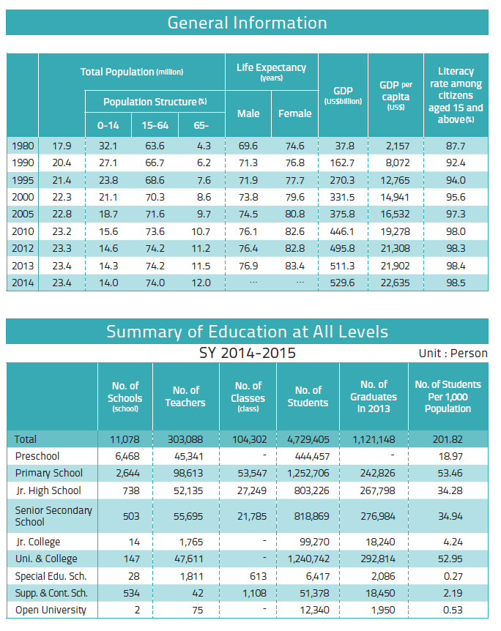

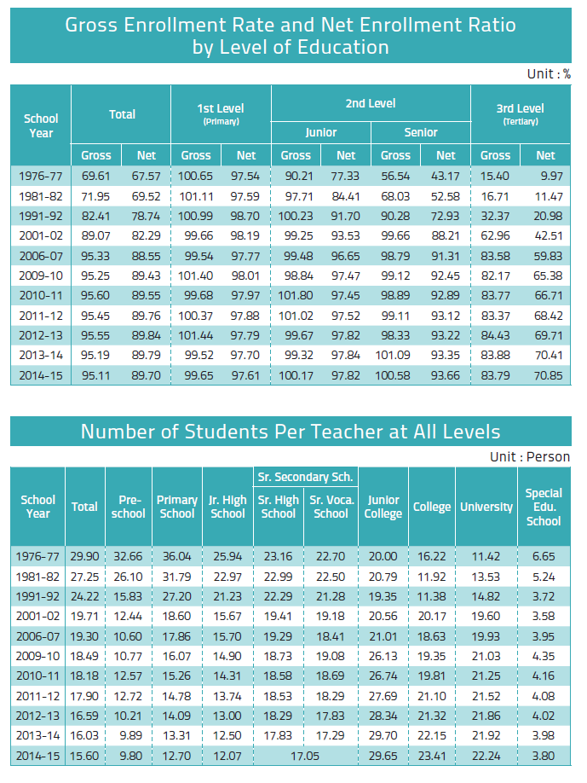

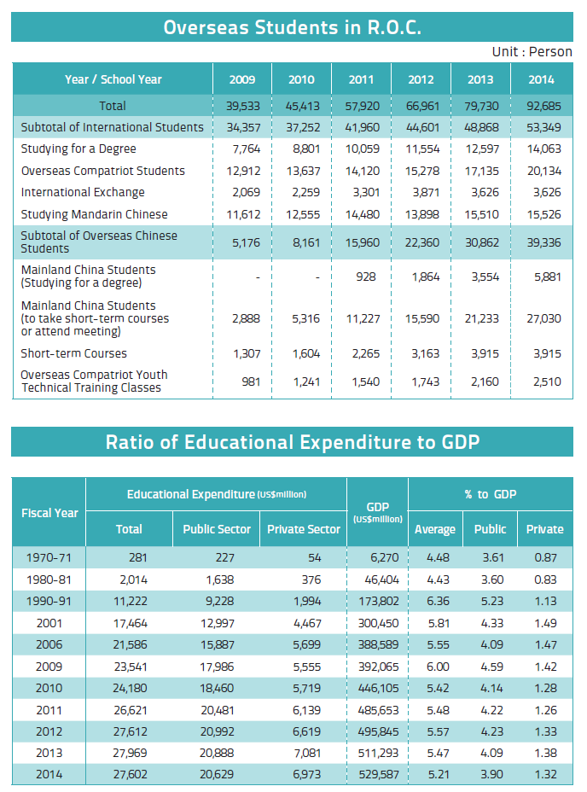

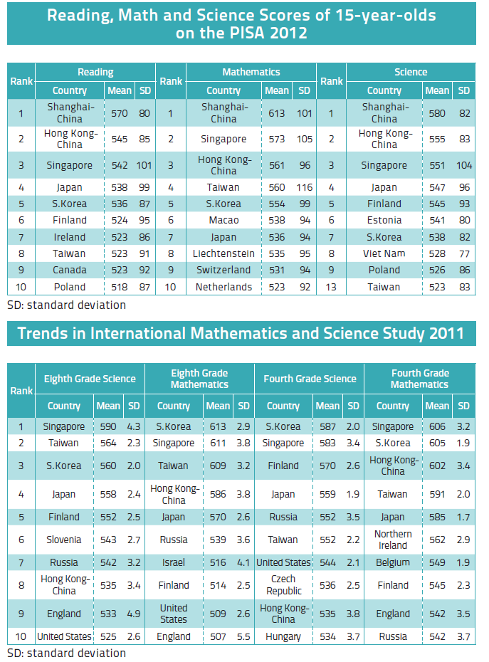

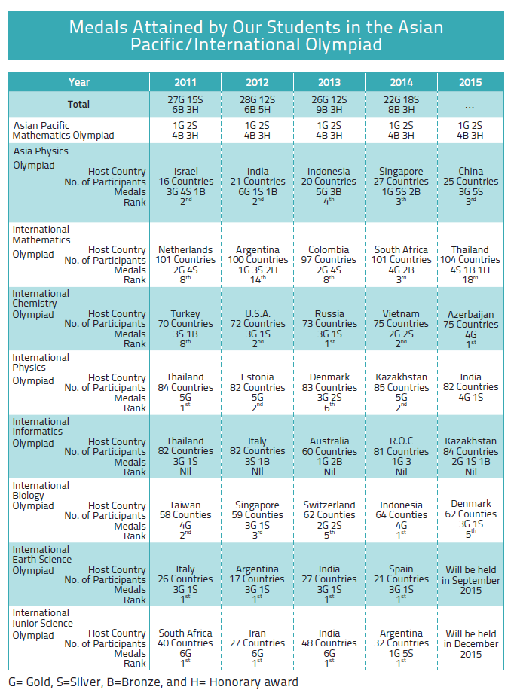

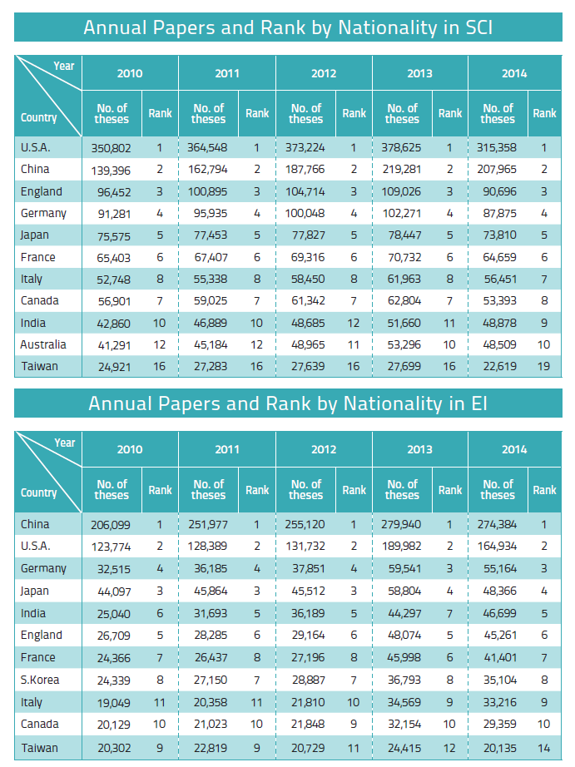

Education in Taiwan
PUBLISHER Se-Hwa Wu (Minister of Education)
EDITORIAL BOARD Department of Statistics
ADDRESS No. 5, Zhongshan S. Rd., Zhongzheng Dist., Taipei City 100, Taiwan ( R.O.C.)
WEBSITE http://www.edu.tw
For more information, please call:
TEL +886-2-7736-6381 (Dep’t of Statistics, MOE )
FAX +886-2-2397-6917
DATE August 2015

Sales
1. Sanmin Book Co., Ltd.
TEL: +886-2-2361-7511 #114
No.61, Sec. 1, Chongqing S. Rd., Zhongzheng District, Taipei City 100, Taiwan ( R.O.C.)
2. Wunanbooks Store
TEL: +886-4-2437-8010
No.6, Zhongshan Rd., Central District, Taichung City 400, Taiwan ( R.O.C.)
3. Government Publication Bookstore
TEL: +886-2-2518-0207 #22
1F, No. 209, Songjiang Rd., Zhongshan District, Taipei City 104, Taiwan ( R.O.C.)
4. MOE Co-Operative
TEL: +886-2-7736-6054
No. 5, Zhongshan S. Rd., Zhongzheng Dist., Taipei City 100, Taiwan ( R.O.C.)
5. Center for Educational Resources and Publishing, National Academy for Educational Research
TEL: +886-2-3322-5558#229
No.181, Sec. 1, Heping E. Rd., Daan Dist., Taipei City 106, Taiwan ( R.O.C.)

IN COOPERATION WITH Taiwan News Corporation
WEBSITE http://www.taiwannews.com.tw
Tel +886-2-2351-7666
PRICE NT$160 US$5 (Including DVD)
GPN 2005900021
ISSN 05781353
Special thanks to HeMei Elementary School (New Taipei City), Siding Elementary School (Chiayi County), Jhongyi Elementary School (Tainan City), Chaung-Wei Junior High School (Yilan County), San Min Junior High School (Hsinchu City), Bin-Mao Junior High School (Taitung County), Kai Ping Culinary School (Taipei City), Ching Cheng High School (Changhua County), National Siluo Agricultural Industrial High School (Yunlin County), National Shui-Li Vocational High School of Commerce and Industry (Nantou County), Cianjhen Senior High School (Kaohsuing City), Oriental Institute of Technology (New Taipei City), Saint Mary's Junior College of Medicine, Nursing and Management (Yunlin County), National United University (Miaoli County), Asia University (Taichung City), National Formosa University (Yunlin County), Chia Nan University (Tainan City), The Provincial Changhua School for the Mentally Retarded (Changhua County), Kaohsuing Municipal Renwu Special School (Kaohsuing City), National Hsinchu Special School (Hsinchu County), National Chengchi University (Taipei City), Chung Yuan Christian University (Taoyuan City), Providence University (Taichung City), Siuthern Taiwan University of Science and Technology (Tainan City), National University of Kaohsiung (Kaohsuing City), Nei-Hu Community College (Taipei City), Jhong Li Community College (Taoyuan City), Chia-Yi Community University (Chiayi City), LuoDong Community University (Yilan County).

